

STAR 5.35b Reference Guide
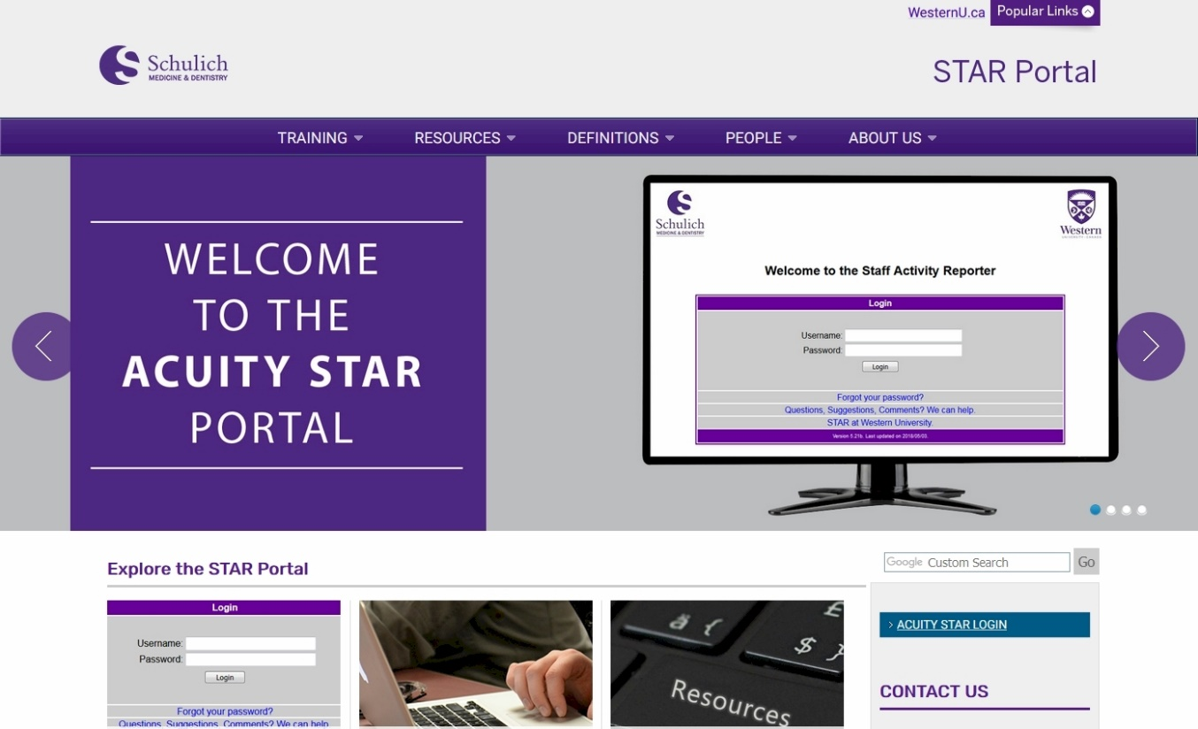
https://www.schulich.uwo.ca/star/
https://star.schulich.uwo.ca
Western University
Schulich School of Medicine & Dentistry

This document contains information about where to save
general information in the STAR system.
Updated for STAR 5.35b
(October 2025)

Section I: What’s New with STAR 5.35? (Page 3)
(2 Pages)
Section II: STAR Interfaces (Page 6)
(1 Page)
Section III: General Overview of STAR (Page 7)
(6 Pages)
Section IV: Quick Reference Guide (Page 13)
(8 Pages)
Section V: Detailed Data Entry Guide (Page 21)
(24 Pages)
Section VI: Glossary (Page 45)
(1 Page)
Section VII: Tips, Tricks and Hints (Page 46)
(10 Pages)
What’s New with STAR 5.35?
What has changed in this version of STAR?
Additional Bulk Editing Options
Where? Supervisory Experience Page, Mentoring & Coaching Page
Why? To allow users to quickly fill a series of values that are identical without having to edit one record at a time.
What? The change is summarized below.
Supervisory Experience Page
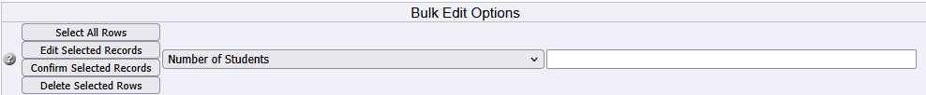
Mentoring & Coaching Page
Add HTML Editing to 3 Fields in STAR
Where? Leadership Evidence Page, Teaching Innovations & Curriculum Development Page
Why? To allow users to better format their data using Bolding, Underlining & Italics.
What? The change is summarized below.
Leadership Evidence Field on the Leadership Evidence Page
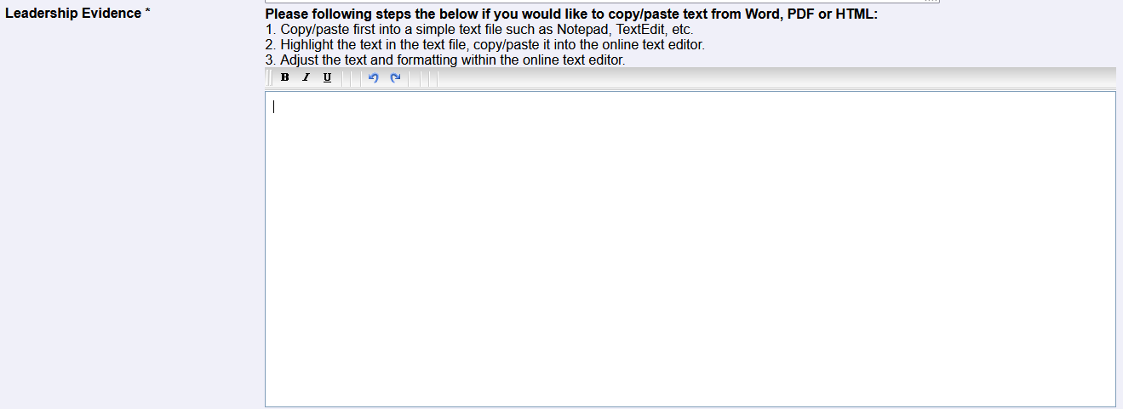

Outcomes Field on the Leadership Evidence Page
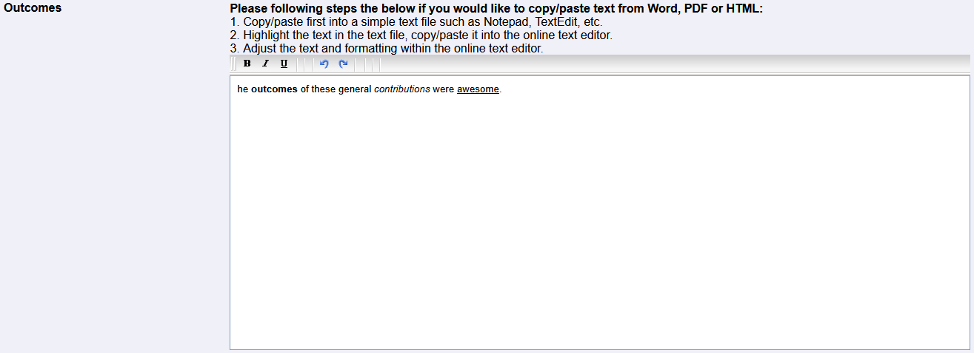
Description / Activity Field on the
Teaching Innovations & Curriculum Development Page

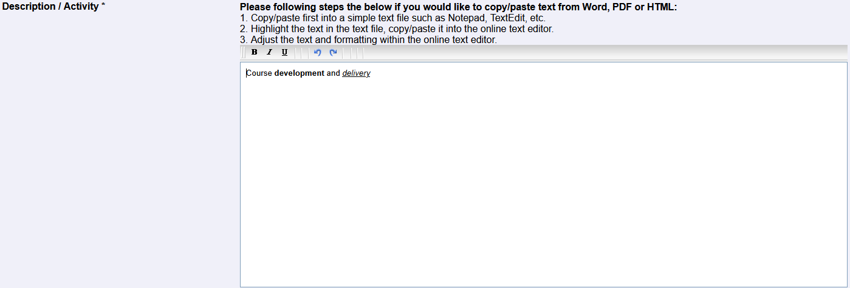

Please contact your STAR coordinator if you have any questions about these updates.
Changes from Previous STAR Updates
Promotion CV Report Generation Options Update:
We have made selected options in the report generation screen of the Professional CV enabled by default. This should make the process of generating the CV faster and easier. Please note that all report options can still be changed as needed.
The options that are now enabled by default include:
The "Include Professional Title in Header" option is SELECTED by default.
The "Print Grants in Table format" option is SELECTED by default, the "Multiple Table" format is also SELECTED by default.
The "Group Presentations by" option is SELECTED by default, and the "Geographic Scope" format is also SELECTED by default.
Teaching Dossier Evaluation Table Options Update:
A checkbox has been added to the report generation screen of the Teaching Dossier Report to allow the exclusion of the teaching effectiveness tables. If there is little or no data in the teaching effectiveness screen for a given member, the tables can be generated with incomplete or misleading results. Please select this option if needed to suppress these tables from the printout.
Import Records from Common CV into StarCV
Where? In the Purple Menu under the Common CV View
Why? To allow users to be able to import Common CV Records into StarCV.
Clear Simple Common CV Export Warnings
Where? On the Common CV Validation / Export Screen
Why? To easily clear some warnings like truncation errors, missing dates, and more.
Add Common CV ID Field to Grid Pages
Where? On any StarCV grid page that exports to Common CV.
Why? To allow administrators and users to identify previously imported records.
Add Simple Text Editing to Teaching Philosophy
Where? On the Teaching Philosophy Page
Why? To allow bold fonts, italics and underlining on the saved Teaching Philosophy.
Publications Impact Field now prints consistently
Where? Report sections that print publications.
What? All reports now print the impact field if it is saved with the publication record.
Harmonize University Name to Western University
Where? Every Picklist, Every Report throughout StarCV
What? Western University is now the Standard name for the university across StarCV
Promotion Documents Update:
Personal Data Menu | Leadership Evidence Printing
A checkbox has been added to the Leadership Evidence page on the Personal Data Menu. This checkbox is titled “Print on Teaching Dossier”. As you would expect, Leadership Evidence records saved with this check box marked as selected will print on the Teaching Dossier report. Leadership Evidence records saved without this check box marked as selected will print on the Promotion CV report.
If it makes sense for your situation, we recommend putting all Leadership Evidence records on the Promotion CV report. If that does not work well for your specific situation, then putting some Leadership Evidence records on the Teaching Dossier is also permitted.
Please contact your STAR coordinator if you have any questions about these updates.
Teaching Dossier Update: Teaching Summaries
This page will accept scanned PDF uploads of teaching summaries that have been
received from teaching sources outside of Western. Please ensure to include the
Geographic Scope (Local, Regional, National, International) to each upload.
These summaries will print at the end of the Teaching dossier in an appendix, and they
will be organized by geographic scope. Note: Generated PDF Files will not print
correctly. The PDF’s must be scanned to be uploaded and print correctly.
Teaching Philosophy – Printing Changing
The Teaching Philosophy will now print any saved Teaching Philosophy record where
the end date is to present or beyond the current date. Records where the end date is
past will no longer print. Also, it is possible to have more than one Teaching Philosophy
if desired.

Please contact your STAR coordinator if you have any questions about these updates.
Custom CV Options
.
What has changed?
A number of new features have been added to the report configuration section of the SSMD Professional CV. These new features make the professional CV much more customizable, and allow Faculty members to generate a full customized CV or a Short CV.
What are the new features?
The new Include time limited activities option will open up a new section which will allow you to include or exclude sections all sections of the CV.
- Sections of the CV can be included or excluded using the checkbox leading that line.
- Different time limitation options can be enabled for every CV section by selecting that feature
- The latest number of entries can be printed by selecting that feature.
- Specific records can be selected to print by marking the desired records as Draft
- Pages not selected in this section will be suppressed.
The new Do Not Print Extra Fields option will allow users to determine how much detail they wish to print on the Professional CV. This option is primarily used for generating Short CV’s.

When checked, the Do Not Print Extra Fields option will omit about half of the fields in STAR that print by default. This is the best option for Short CV’s. When not checked, the Do Not Print Extra Fields option will allow all relevant fields to print on the CV unfiltered.

The new Print Grants in Table Format option will allow users to choose the look of how Grants are displayed in the CV. The Single Table Format option is primarily used for generating Short CV’s. The Citation of Multiple table formats are just personal preference.

Leaving the Print Grants in Table Format unchecked will print the grants section in citation format. When the Print Grants in Table Format option is checked, it will give you the option to have it print in single table format (for short cv) or multi table format.

Please contact your STAR coordinator if you have any questions about these updates.
General Overview of STAR 5.35
STAR was originally designed as a tool for department administrators to use to create and manage aggregate reports for department chairs. The end user experience was not considered important when the program was initially designed. Until now, the end user experience of STAR came secondary to its administrative power.

Member Secretaries, who have used STAR intermittently in the past, have faced two steep learning curves to use the software effectively. The first learning curve faced by secretaries is the lack of in-depth knowledge of the activities that faculty engage in throughout the course of their day. The second steep learning curve they face is to know where to place those activities properly in STAR, and what information is required to record in STAR.

To address the first learning curve, we are creating a self-directed course on understanding the CV recordable activities performed by faculty at Schulich.

The second learning curve is improved by this new version of STAR, which aims to enrich the end user experience by making it more intuitive and efficient. This will be accomplished by the use of a new dynamic menu system, which allows the user to select the exact menu options which are found on the SSMD Professional CV. Using the SSMD Professional CV view, in conjunction with the All Activities view will give the user a couple of different methods to find and record the data correctly in STAR.
Logging in to STAR
Logging in to STAR is the same as logging in to previous versions of STAR. As with all previous versions of STAR, a valid username and password are required in order to gain access to the system.
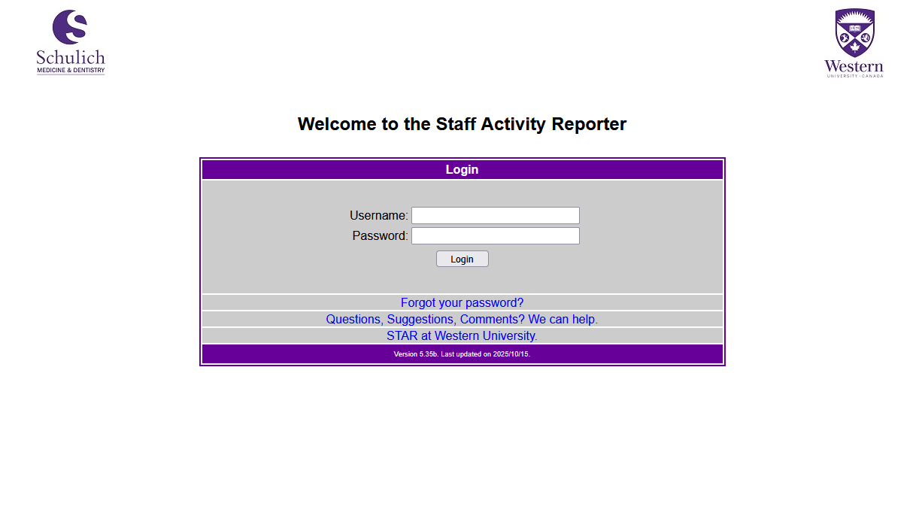
Figure 1.1 Login Page
- All Activities View
The All Activities View is the main menu of the STAR application. Clicking on any of the top level or sublevel menus will accordion ‘open or closed’ to ‘expand or contract’ any of the available STAR menus.

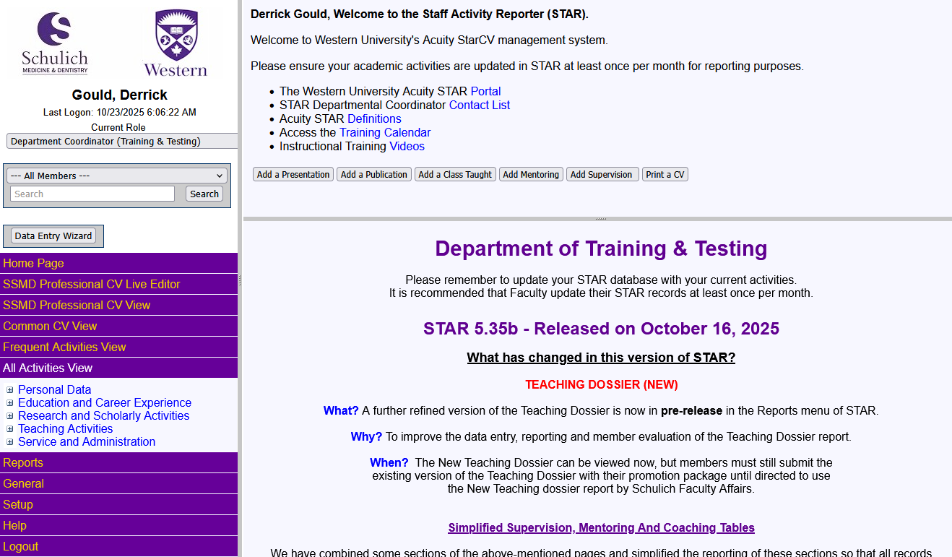
Fig 1.2 All Activities View

Things to remember:

- Sorting is possible on any column, ascending or descending
- The grid columns link allows you to select the columns you wish to see at any time
- Bulk Edit link will allow you to change information in the same field across multiple records
- The slider bar between window panes can be moved left or right at any time
- Ctrl (+) will enlarge the screen text size, Ctrl (–) will decrease the screen text size
- When clicking on MENU links, the content pane will remain blank
- When clicking on PAGE links, the content pane will show the data grid
- If you have multiple roles, you can select the desired role at the top of the menu pane

- Professional CV Live Editor
The Professional CV Live Editor is the newest and most exciting menu used in STAR. The Live Editor allows the user to edit their CV in WYSIWYG mode, directly in the browser. It is like editing the CV in word, except the changes made in the browser are saved to the STAR database.
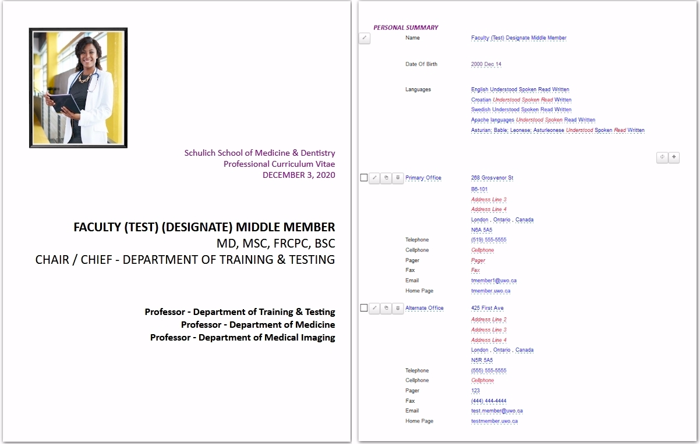
- SSMD Professional CV View
The SSMD Professional CV view is a new dynamic menu which shows users all possible menu options for their Professional CV, and sorts the displayed data in the same way as the data is printed on the SSMD Professional CV.
STAR users can print their SSMD Professional CV and use the actual report headings to guide their menu choice selections. At any time, the user can switch back to the “All Activities View” to allow them to use the traditional data grid if they wish.

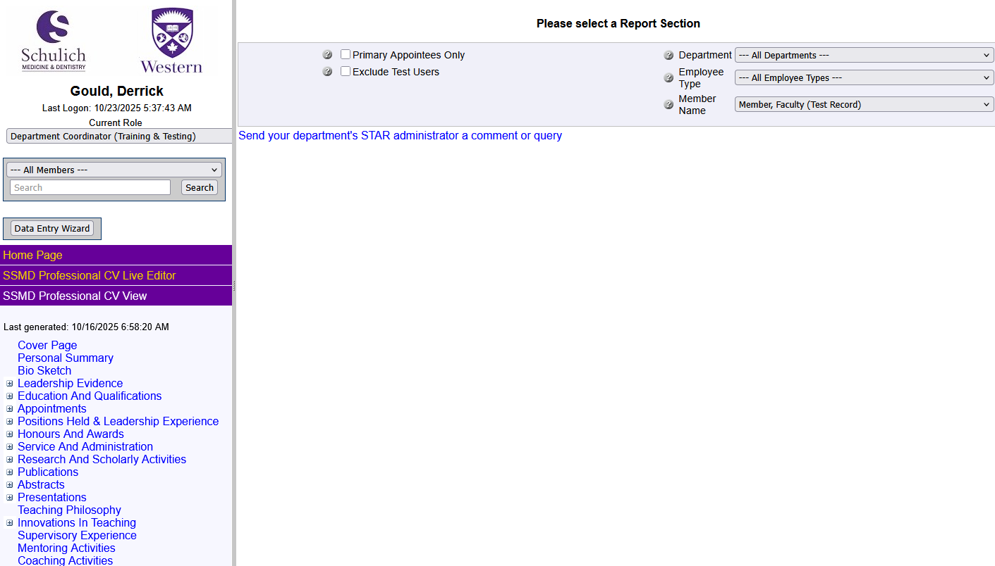
Fig 1.3 SSMD Professional CV View

Things to remember:

- In the SSMD Professional CV View, the menu is generated from the CV headings
- Sorting is NOT possible on any column, because the order is the same as on the printed CV
- The grid columns link is not available, as all of the columns that print on the cv are shown
- The slider bar between windowpanes can be moved left or right at any time
- Ctrl (+) will enlarge the screen text size, Ctrl (–) will decrease the screen text size
- When clicking on MENU links, the content pane will remain blank
- When clicking on PAGE links, the content pane will show the data grid
- If you have multiple roles, you can select the desired role at the top of the menu pane
- Records can now be moved from one section to another, but only if the top-level page is the same in the record you are moving from and to.
- Records cannot yet be moved from one top level page to another, as many of the fields in the top level pages do not line up.

- Frequent Activities View
The Frequent Activities View is a compilation of the most used screens of the STAR application.
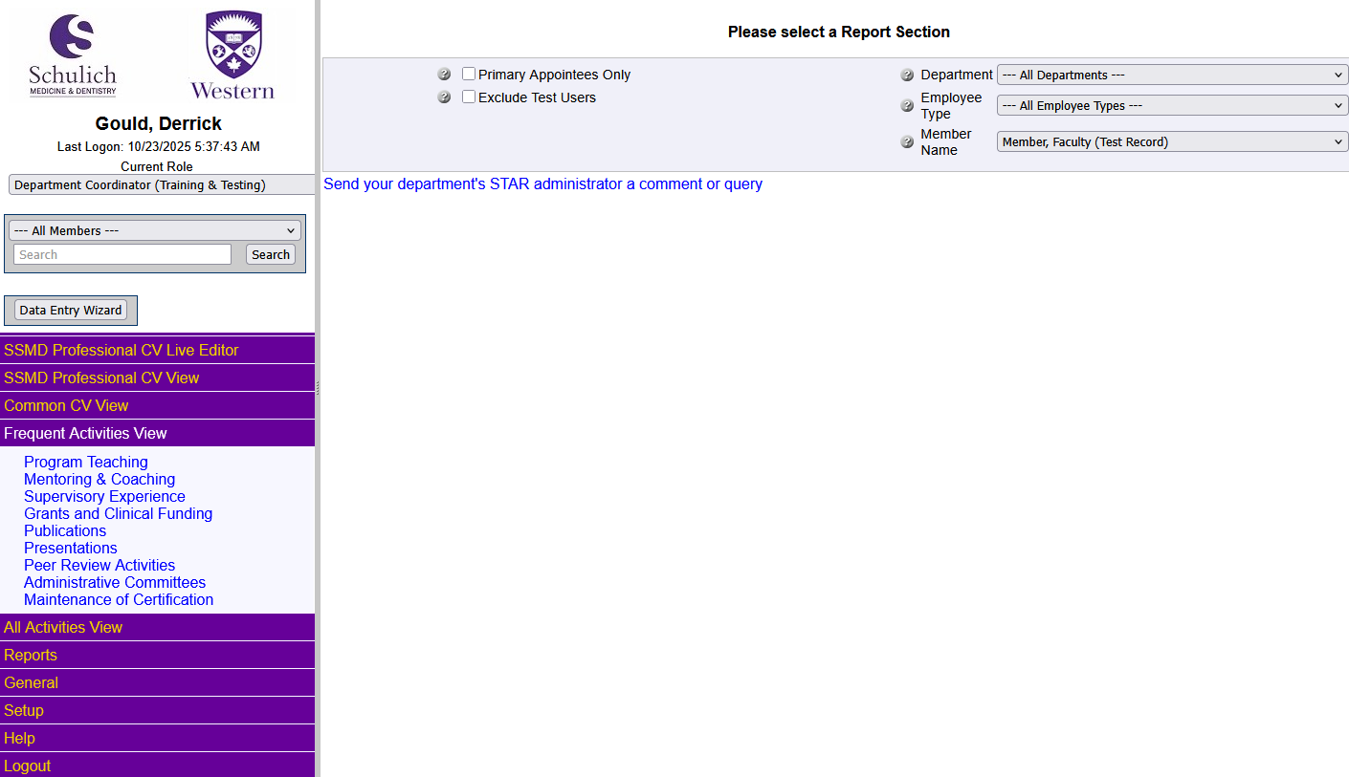
Fig 1.4 Frequent Activities View

Things to remember:

- Sorting is possible on any column, ascending or descending
- The grid columns link allows you to select the columns you wish to see at any time
- Bulk Edit link will allow you to change information in the same field across multiple records
- The slider bar between windowpanes can be moved left or right at any time
- Ctrl (+) will enlarge the screen text size, Ctrl (–) will decrease the screen text size
- When clicking on MENU links, the content pane will remain blank
- When clicking on PAGE links, the content pane will show the data grid
- If you have multiple roles, you can select the desired role at the top of the menu pane

- Common CV View
The Common CV view provides access to the Common CV Validation / Export tool, and also to the Common CV Import tool.
Exporting from StarCV and then Importing to CommonCV.
  - When the activities are imported from StarCV to Common CV, Common CV automatically deletes all entries in the categories that contain data to be imported, and then replaces the old data with whatever new data exists in the import file.
Exporting from CommonCV and then Import to StarCV
  - When activities are imported to StarCV The first time from Common CV, records imported will be duplicated if those records already exist in StarCV. When the records that were imported from CCV are saved in StarCV, those records will have a CCVID field added to the record containing a record number from common CV.
  - When subsequent imports from CCV to StarCV are performed. those records that already have an ID number in the CCV-ID field will not be duplicated. It is the existence of the ID in the CCV-ID field in StarCV that prevents the duplication.
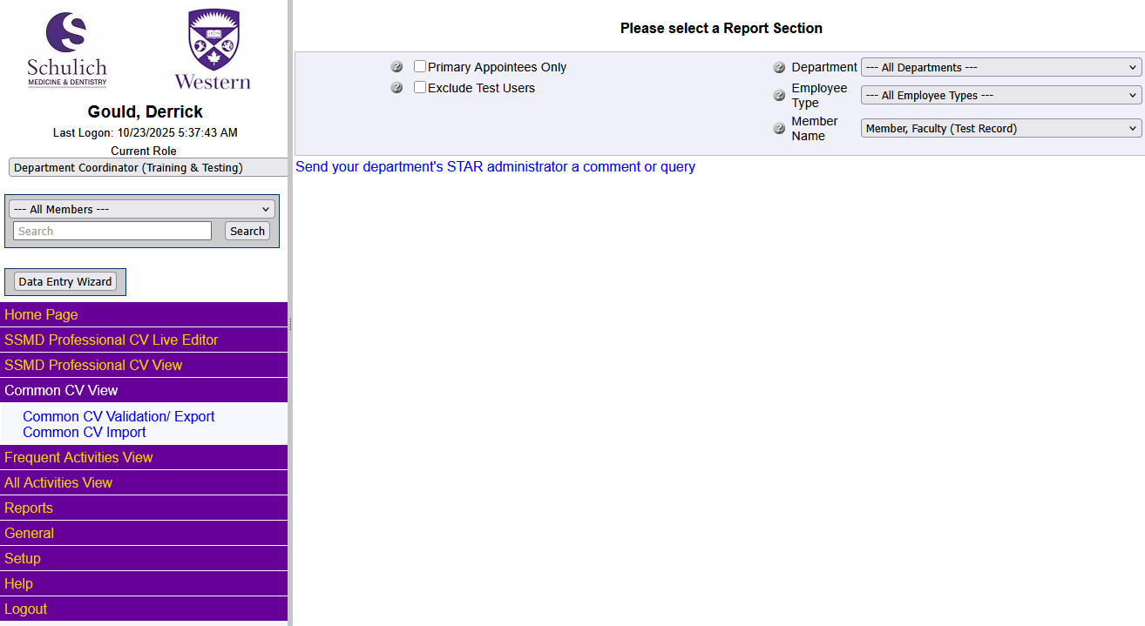
Fig 1.5 Common CV View
The validation/export tool will verify that the any of the data saved in STAR is complete before it is sent to Common CV.

This tool provides the user with a validation summary screen which details the records in STAR which need to be amended prior to uploading the STAR data to Common CV.

When presented with a list of errors and warnings, the user can quickly remove any records that are older than 5 years from the current date by checking the checkbox on the export page in StarCV. (CommonCV will not import any records older than 5 years, so there is no need to update any records in StarCV that are older than 5 years.

Also, users can quickly remove any errors or warnings about data being truncated when the data is sent to CommonCV because those errors are not able to be fixed without removing valuable data from StarCV. To accomplish this, the user simply checks the remove truncated warnings checkbox on the export page in StarCV.

Users can also have CommonCV set any missing months to a specified value on the report generation screen. In these cases, any data where the month is required by CommonCV, but not saved in StarCV, the StarCV export tool will send whichever month the user specifies to CommonCV when a missing month error is encountered.

Once all the Warnings and Errors have been corrected, the user can click on the “Generate XML” button, which will queue the STAR system to generate an XML file which can be saved and then uploaded to the Common CV system.

- “Highlight related fields for” pick list
A pick list labeled “Highlight related fields for:” is available on each data form page in the data form popup window. This pick list allows users to select from a list of reports available to the user, and will highlight the fields on this page, related to that report.
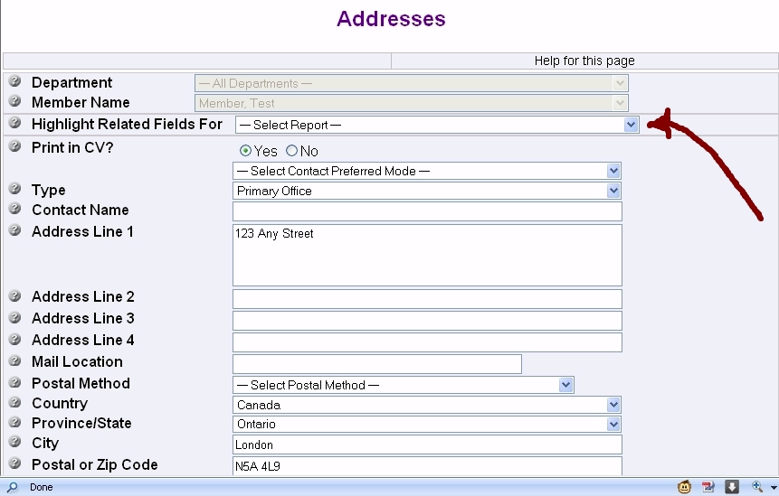
Figure 1.5. "Highlight Related Fields For:" pick list on each data form

Related fields include all fields that print on the selected report, or any field that is used for sorting, filtering and or grouping in that report.

Upon selecting a report from the “Highlight Related Fields For:” pick list, the entry fields related to that report will be highlighted in yellow. This allows the user to quickly see which information will be displayed on the selected report, once entered. It is important to note that the highlighting only applies to the set of fields a user can see in the application.

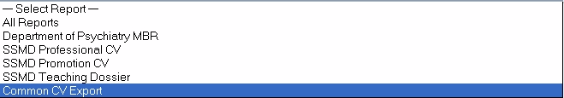
Figure 1.6 "Highlight Related Fields For:" Pick list close-up

STAR 5.35 Quick Reference Guide
MAIN MENU – HOME PAGE
Home:
The home page link will return the user to the default page with the system welcome message and the department welcome message.

SSMD PROFESSIONAL CV LIVE EDITOR – MENU
Dynamically Generates CV in an HTML View:
This menu option dynamically generates the user’s CV in an HTML window, and allows the user to edit the CV much like a Word Document. Please ensure that your popup blocker is set to allow popups from this server, and after selecting which options to generate the CV with, a new window will appear to allow the user to edit the CV.

Features we will be adding to this interface in the near future include: Cloning, Ensuring that all mandatory fields appear without having to click ‘more’, and others. Please send your STAR coordinator any suggestions for improvement.

SSMD PROFESSIONAL CV VIEW – MENU
Dynamically Generated Menu:
This menu is dynamically generated for each member and consists of menu options which exactly match the titles and options of the SSMD Professional CV report. To use this view, have a copy of the SSMD Professional CV handy, and you can use it to help navigate the menu.

Each of the main menus in the SSMD Professional CV view are the titles printed in bold purple letters on the SSMD Professional CV itself. By locating each of the subheadings in the report, you can navigate through the menus in the view.

COMMON CV VIEW – MENU
Common CV Validation / Export:
This function will run a validation script against the STAR database to ensure that all of the data fields in the pages related to Common CV contain valid information. Any information which MUST BE corrected prior to upload will be marked as a CRITICAL ERROR, and critical errors cannot be bypassed to generate an XML file. These errors must be corrected before the user can proceed to generate an XML file.
Other errors which SHOULD BE corrected, but are not critical errors, are called WARNINGS. Warnings should be corrected, but if the user chooses not to correct a warning, the XML file can still be generated; however, the STAR data record which contains the warning will not be included in the file.

When an XML file is generated, the STAR program will generate a dialogue box, which will give the user an opportunity to select where to save the file.

NOTE: Please do not change the file name when the file is saved to the local computer.

ALL ACTIVITIES VIEW MENU - PERSONAL INFORMATION
Personal Data Summary:
This section contains personal Information about a UWO Faculty member.
A studio portrait style picture can be added to this page.
BioSketch information can be added to this page.
It is highly recommended NOT to record SIN number in STAR, even though there is a place for it.
It is also recommended that Date of Birth should not be entered into STAR.
Instructions are in Section 2.1 of the Detailed Data Entry Guide in this Document.

Hospital Appointments:
This section can only be updated by Domain Administrators for your department.
Any clinical appointment to a hospital position.
Recorded from first appointment date.
Multiple appointments are possible.
Please contact your department Coordinator to have these records updated or corrected.

University Contract:
This section can only be updated by Domain Administrators for your department.
A simple contract record indicating the dates of employment to a UWO faculty position.
This record does not print on any UWO CV format. Multiple contracts are not possible.
Please contact your department Coordinator to have these records updated or corrected.
University Rank History:
This section can only be updated by Domain Administrators for your department. A UWO faculty position rank history. Typically recorded from July 1 to June 30.
Multiple appointments are possible. Recorded from first appointment date.
Please contact your department Coordinator to have these records updated or corrected.
Western Appointments:
This section can only be updated by Coordinator for your department.
Multiple appointments are possible. Recorded from first appointment date.

Addresses:
Multiple Address Record types are possible.
It is recommended to have a ‘Primary Office’ record; a ‘Home’ address record is optional.
Instructions are in Section 2.7 of the Detailed Data Entry Guide in this Document.
Leadership Evidence:
This section contains information demonstrating evidence to a Faculty member’s ability to lead.
For example, research awards won by students.
Instructions are in Section 2.8 of the Detailed Data Entry Guide in this Document.
Department / Division Meetings Attended:
This section records any internal department or division meeting, and will not be printed on any CV.
Instructions are in Section 2.9 of the Detailed Data Entry Guide in this Document.
Maintenance of Certification:
This section records any CME event attended.
CME Events where the faculty member gave a presentation at Western should be in Program Teaching.
CME Events where the faculty member gave a presentation outside Western should be in Presentations.
Instructions are in Section 2.10 of the Detailed Data Entry Guide in this Document.
Areas of Interest:
Instructions for Areas of Interest are in Section 2.11 of the Detailed Data Entry Guide in this Document.
ALL ACTIVITIES VIEW MENU - EDUCATION AND CAREER EXPERIENCE:
Education:
Formal education such as Degrees and Diplomas.
Includes the option to include a thesis title.
Instructions are in Section 3.1 of the Detailed Data Entry Guide in this Document.
Research Training:
This section records any specific research training taken.
Instructions are in Section 3.2 of the Detailed Data Entry Guide in this Document.
Other Specialized Training:
This section records any training related to the area of specialty.
This section should not contain records for CME events attended.
CME events attended should be on the Maintenance of Certification screen.
Instructions are in Section 3.3 of the Detailed Data Entry Guide in this Document.
Qualifications, Certifications and Licenses:
Fill out at least Title, Institution / Organization and Dates.
Instructions are in Section 3.4 of the Detailed Data Entry Guide in this Document.
Professional Associations:
Groups that a faculty member may belong to but is not necessarily required to attend regular meetings.
Dues may or may not be charged for membership.
Fill out at least Role, Association Name, and dates.
Instructions are in Section 3.5 of the Detailed Data Entry Guide in this Document.
Positions Held and Leadership Evidence:
Cross Appointments from Faculties outside the Clinical Departments at Schulich are listed here
Western Appointments and Hospital Appointments should not be placed here.
Instructions are in Section 3.6 of the Detailed Data Entry Guide in this Document.
Honours and Awards:
Education honours and awards are listed here
Fill out at least Award Name, Description of Award, Institution / Organization & Dates
Instructions are in Section 3.7 of the Detailed Data Entry Guide in this Document.

ALL ACTIVITIES VIEW MENU - RESEARCH AND SCHOLARLY ACTIVITIES:
Research Endeavours:
A brief narrative about the faculty member’s research interests.
Instructions are in Section 4.1 of the Detailed Data Entry Guide in this Document.
Patents and Copyrights:
Simple Listing of patents and copyrights earned.
Instructions are in Section 4.2 of the Detailed Data Entry Guide in this Document.
Grants:
All research grants (industry, non-industry, peer-reviewed and not peer-reviewed).
Please fill in the information completely including as much detail as possible.
Please ensure to save month information where known.
Update these records as new or additional information becomes available.
Instructions are in Section 4.3 of the Detailed Data Entry Guide in this Document.
Publications:
Record all publications including electronic media (e.g. CD-ROMs, videos, DVDs, and web content).
Multiple records can be imported at one time.
Instructions are in Section 4.4 of the Detailed Data Entry Guide in this Document.
Presentations:
All presentations except those presented as Program Teaching at Schulich.
Instructions are in Section 4.5 of the Detailed Data Entry Guide in this Document.
Peer Review Activities:
This section includes Editorial Boards, Grant Reviews, Manuscript Reviews, and Journal Article Reviews
Instructions are in Section 4.6 of the Detailed Data Entry Guide in this Document.
Other Professional Research Activities:
Other professional research activities may include: membership on a program committee of a conference, reviewing research papers, organizing conferences or other research events.
Instructions are in Section 4.7 of the Detailed Data Entry Guide in this Document.
Endowed Chairs and Other Funding:
An endowed chair is a position that is paid with the revenue from an endowment fund. Typically, the position is designated to be in a certain department. The donor can name the position, which typically takes the format: First-name Last-name professorship of Department-name.
Instructions are in Section 4.8 of the Detailed Data Entry Guide in this Document.
ALL ACTIVITIES VIEW MENU – TEACHING ACTIVITIES
Program Teaching:
Program Teaching is meant for any medical school teaching at Schulich. (UME, PME, CME, UDE, OTHER)
Undergraduate Medical Education is for didactic ‘lecture hall’ type sessions for medical students.
Postgraduate Medical Education is typically small group contact teaching in the form of resident lectures, etc.
Continuing Medical Education may be in the form of Rounds, Lectures, etc.
Visiting professorships for Schulich faculty must not be placed in this category.
Visiting professorships are correctly placed in the Presentations section with a ‘Role’ of Visiting Professor.
Instructions are in Section 5.4 of the Detailed Data Entry Guide in this Document.
Clinical Teaching:
Clinical teaching is teaching and learning that is focused upon, and usually directly involves, patients and
their problems.
Instructions are in Section 5.4 of the Detailed Data Entry Guide in this Document.
Teaching Awards:
Awards received for teaching.
Instructions are in Section 5.3 of the Detailed Data Entry Guide in this Document.
Teaching Innovations and Curriculum Development:
Teaching or learning methods and/or tools that have been successful in advancing the education of medical students.
Instructions are in Section 5.4 of the Detailed Data Entry Guide in this Document.
Teaching Effectiveness:
Teaching effectiveness scores may be entered manually into STAR for most departments.
Dept of Medicine administration imports One45 teaching effectiveness scores into STAR for DoM faculty..
Instructions are in Section 5.5 of the Detailed Data Entry Guide in this Document.
Mentoring Activities:
The expectation for the medical mentor is flexible, but the recommendation is for the mentor to
spend a minimum of 4 hours per week with the student.
Instructions are in Section 5.7 of the Detailed Data Entry Guide in this Document.
Student Supervision:
Formal supervision of medical students, residents, fellows, or graduate students.
Instructions are in Section 5.7 of the Detailed Data Entry Guide in this Document.
Teaching Philosophy:
A Teaching Philosophy entered into the philosophy of education heading.
Teaching philosophies may not exceed 4000 characters
Instructions are in Section 5.8 of the Detailed Data Entry Guide in this Document.

ALL ACTIVITIES VIEW MENU - SERVICE AND ADMINISTRATION
Administrative Committees:
Any committee of which the faculty member is an active member regardless of role
(i.e. chair, advisor, member) Instructions are in Section 6.1 of the Detailed Data Entry Guide in this Document.
Other Noteworthy Activities:
Activities that cannot reasonably be captured in any other area of the STAR system may be entered here.
Instructions are in Section 6.3 of the Detailed Data Entry Guide in this Document.

ALL ACTIVITIES VIEW MENU - CLINICAL ACTIVITIES
Clinical Profile:
This selection is not used and is enabled for some departments.
We are working with Schulich and Department administrators to configure and enable this feature for all departments.
Instructions for Clinical Profile are in Section 7.1 of the Detailed Data Entry Guide in this Document.
MAIN MENU - REPORTS

SSMD Professional CV - Available Now
Usage: Full Primary CV
Can be modified as a Word document to create various short CV versions.
This UWO faculty standard CV report contains all activities in the STAR database except:
- Department / Division Meetings Attended
- Time Allocation
- Goal Setting and Review
- Clinical Teaching
- Clinical Profile

SSMD Teaching Dossier - Available Now
Usage: Mandatory for Promotion and Tenure - Complete Teaching Dossier
This report can function as a standalone Teaching Dossier.
It is planned that teaching effectiveness scores from One45 will soon be automatically added to this report.

SSMD Promotion CV - Available Now
Usage: Mandatory for Promotion and Tenure – CV without Teaching Information
This report when coupled with the APTD contains all activities in the STAR database except:
- Department / Division Meetings Attended
- Time Allocation
- Goal Setting and Review
- Clinical Profile
All activities in STAR not captured on the APTD are contained in this report.

Common CV Data Export –Limited Release
Usage: Grant Applications
This option is available with some limitations. Please contact your STAR coordinator for more information.
- Save data in STAR
- Validate data in STAR
- Generate XML file
- Upload XML file to Common CV
- Parse the exported STAR records
- Import selected records.

BioSketch - Available Now
Usage: Presentation Introduction
This one-page report contains the faculty portrait, and the BioSketch paragraph describing the
member's career.

Faculty Assessment Summary - Available Now
Usage: Department of Medicine – Teaching Evaluations via Data Imported from One45
Retrieve all records that occur in a specified time period.
Use preformatted template to evaluate faculty member evaluations, comparing their scores to:
- members who taught the same rotation that year,
- members in their division,
- members in their department.
MAIN MENU - GENERAL
Data Certification:
Allows the user to certify that the database is up to date as of the current date.
Can be modified at any time.
Please contact your department Coordinator if you have questions about the privacy feature.

Database Audit:
Allows the user to search all STAR pages for records which contain blank mandatory fields.
Please contact your department Coordinator if you have questions about the privacy feature.

Change Password:
Please use this screen to update your password as you require.
There is not currently a required timeframe to change your password.
It is recommended to change your password at least once every 3 months.
Instructions are in the Detailed Data Entry Guide in this Document.
Personal Settings:
Allows the user to turn the privacy feature on or off.
Please contact your department Coordinator if you have questions about the privacy feature.

Action List:
Please contact your department Coordinator if you have questions about the action list.
Time Allocation:
This screen records the time allocation values agreed upon with Medical affairs and the UWO faculty member.
These values will be manually entered by department administration into the system in the short term
This process will be updated once the CDP Documents are automated.
This section will not be printed on the CV.
This section will print on the CDP once automated.

Contact Us:
Please use this screen to quickly enable you to contact your department Coordinator.
Logout:
Please click the logout link when you are finished with STAR.
This will help to keep your data safe from hackers.

MAIN MENU - HELP

Help:
Opens the HTML help file.
Documentation:
STAR 5.35 Reference Guide|
Monthly Data Entry Reminder Form

MAIN MENU - LOGOUT

Logout:
This command closes your session and logs you out of STAR.
STAR 5.35 Detailed Data Entry Guide
Detailed Index:
1 General 24
1.1 Change Password 24
1.1.1 Password Changes 24
1.2 Contact Us 24
1.2.1 Send a question to your Department STAR Coordinator 24
1.3 Logout. 24
1.3.1 Simple Logout 24
2 Personal Data 25
2.1 Personal Data Summary 25
2.2 Hospital Appointments 26
2.3 University Contract 26
2.4 University Rank History 26
2.5 Western Appointments 26
2.6 Addresses 26
2.7 Leadership Evidence 27
2.8 Department / Division Meetings Attended 27
2.9 Maintenance of Certification 28
2.10 Areas of Interest 28
3 Education and Career Experience 29
3.1 Education 29
3.2 Research Training 29
3.3 Other Specialized Training 30
3.4 Qualifications, Certifications and Licenses 30
3.5 Professional Associations. 30
3.6 Positions Held 31
3.7 Honours and Awards 32
4 Research and Scholarly Activities 33
4.1 Research Endeavors 33
4.2 Patents and Copyrights 33
4.3 Grants 34
4.4 Publications 35
4.5 Presentations 36
4.6 Peer Review Activities 36
4.7 Other Professional (Research) Activities 37
4.8 Endowed Chairs and Other Funding 37
5 Teaching Activities 38
5.1 Program Teaching 38
5.2 External Teaching Summaries 38
5.3 Clinical Teaching 39
5.4 Teaching Awards 39
5.5 Teaching Innovations / Curriculum Development 39
5.6 Teaching Effectiveness 40
5.7 Mentoring Activities 40
5.8 Supervisory Experience 41
5.9 Teaching Philosophy 41
6 Service and Administration 42
6.1 Administrative Committees 42
6.2 Other Noteworthy Activities 42
7 Reports
8.1 Reports 44
8 Help 45
8.1 Help 45
8.1.1 First Level Support 45
8.1.2 Second Level Support 45
8.1.3 Third Level Support 45
8.2 Documentation 45
8.2.1 Available Documents 45

Main Menu - General

Change Password
“The Change Password screen will allow you to input your current password, and select a new, secure password. The password currently has no restrictions but should follow some simple security guidelines. Passwords are not visible to administrators and can only be reset if lost.”
Step 1> Select Menu: General
Step 2> Select Page: Change Password
Step 3> Field: Existing Password <Type current password>
Step 4> Field: New Password <Type new password>
Step 4> Field: Retype Password <Retype new password>

Contact Us
“The Contact Us screen will allow you to send a question or a comment to your departmental STAR Coordinator or to the Faculty Administrator. All questions will be sent via a text box in a pop-up window and will be sent directly to the e-mail inbox of the STAR Coordinator or the Faculty Administrator. All replies to you will come directly to your e-mail inbox.”

Send questions to your STAR Coordinator
Step 1> Select Menu: General
Step 2> Select Page: Contact Us
Step 3> Field: Message <Type Message>
Step 4> Click Send

Logout
“The Logout link will close your active STAR session and log you out of STAR. You can then click on the Login button to return you to the STAR login screen.

Simple Logout
Step 1> Select Menu: General
Step 2> Select Page: Logout

All Activities View - Personal Data

Personal Data Summary
“The Personal Data Summary page records the faculty member's personal information such as name, languages skills, a bio sketch, Academic Role Category (ARC), and a photograph if desired.”
Step 1> Select Menu: Personal Data
Step 2> Select Page: Personal Data Summary
Step 3> Field: Existing Password <Type current password>
Step 4> Field: <fill in all fields in order top to bottom>
Step 5> Field: Common Designate <Nickname or non-legal name>
Step 6> Field: Birth date <Do not include this information>
Step 7> Field: PubMed Physician ID Number <Future Use>
Step 8> Field: Social Insurance Number <Do not include this information>
Step 9> Field: AFP Association <Not Used>
Step 10> Field: UWO ID <Future Use>
Step 11> Field: BioSketch <Copy & paste a paragraph or two describing faculty member’s career>
Step 12> Field: Other Details <Add any other details>. (Does not print)
Once all fields are completed, click the ‘save’ button.

Hospital Appointments
“This page records the Faculty Member's hospital appointment(s) including the faculty member's Primary hospital appointment (the department and division of primary affiliation) plus any secondary hospital appointments. This page has been designated as read only, if there are errors in the information, please contact your STAR Coordinator.”

Western Contract
“Basic information concerning a faculty member's contract with The University of Western Ontario. The only details captured are initial rank and start date. This page has been designated as read only, if there are errors in the information, please contact your STAR Coordinator.”

Western Rank History
“This page captures the history of a faculty member's Western rank and should be in sync with Western Universities’ records. This page has been designated as read only, if there are errors in the information, please contact your STAR Coordinator.”

Western Appointments
“This page records the Primary and Cross appointments with the University of Western Ontario. It has been designated as read only, if there are errors in the information on this page, please contact your STAR Coordinator.”

Addresses
“The Addresses screen allows the addition of addresses related to a physician. These include, among others, Primary Office, Home Office, and Alternate Office. Several addresses may be recorded but only one address may be printed on the CV. Click Yes on the radio button on the record with the specific address you want to print on the CV.”

STEP BY STEP DETAILED INSTRUCTIONS:
Step 1> Select Menu: Personal Data
Step 2> Select Page: Addresses
Step 3> Field: <fill in all fields in order top to bottom>
Step 4> Field: Type <Select type of address>
Step 5> Field: Address Lines 1-4 <All optional>
Step 6> Field: Mail Location <not used>
Step 7> Field: Postal Method <not used>
Step 8> Field: Cell phone, Pager <Not Recommended>
Step 9> Field: Dates <Only if a move is planned>
Step 10> Field: Save as Draft Entry <Selected if you want to review this field later>
Step 11> Field: Other Details <Add and other details>. (Does not print)
Once all fields are completed, click the ‘save’ button.
List of address types: Primary Office, Alternate Office, Home, Mailing,
Secretary, Private, Temporary, Courier

Leadership Evidence
“This page records any instance of public or professional leadership. Such activity may be related to teaching, research, scholarly activities, government, or service and administration. This page is of particular use at Promotion & Tenure review. The Leadership Evidence screen will allow you to input any information to attest to the leadership capabilities of the physician. This page is used in the Teaching Dossier, but not used on the CV.”

STEP BY STEP DETAILED INSTRUCTIONS:
Step 1> Select Menu: Personal Data
Step 2> Select Page: Leadership Evidence
Step 3> Field: Contribution Area <Select Area from Pick list>
Step 4> Field: Leadership Evidence <Copy & Paste or free type evidence description> (2048 Char Limit)
Step 5> Field: Start – End Dates <Select appropriate dates from Pick list>
Step 6> Field: Save as Draft Entry <Selected if you want to review this field later>
Step 7> Field: Other Details <Add and other details>. (Does not print)
Step 8> Field: Leadership Title <Add Leadership Title>

Department / Division Meetings Attended
“The Department / Division Meetings Attended screen will allow you to input any meeting attendance required to be measured by the department or division. This is only to be used for internal meetings at Western. Accredited meetings are to be recorded in the Maintenance of Certification page in the Personal Data Section.”
Entries on this page do not print on any CV or TD.

STEP BY STEP DETAILED INSTRUCTIONS:
Step 1> Select Menu: Personal Data
Step 2> Select Page: Department / Division Meetings Attended
Step 3> Field: Meeting Name <Add Meeting Name>
Step 4> Field: Start – End Dates <Select appropriate dates from Pick list>
Step 5> Field: Hours <Add number of hours>
Step 6> Field: Save as Draft Entry <Selected if you want to review this field later>
Step 7> Field: Other Details <Add and other details>. (Does not print)

Maintenance of Certification
“The Maintenance of Certification screen will allow you to record any Roles in Conferences, courses or meetings where the physician would receive accreditation which would be attributed to Royal College credit towards that years Maintenance of Certification.”

STEP BY STEP DETAILED INSTRUCTIONS:
Step 1> Select Menu: Personal Data
Step 2> Select Page: Maintenance of Certification
Step 3> Field: Royal College / CCFP Section <Select from Pick list>
Step 4> Field: Activity Type <Select from Pick list>
Step 5> Field: Activity Description <Add a description / name of event>
Step 6> Field: Institution / Organization <Enter the host organization>
Step 7> Field: Start – End Dates <Select appropriate dates from Pick list>
Step 8> Field: Hours <Add number of hours>
Step 9> Field: Save as Draft Entry <Selected if you want to review this field later>
Step 10> Field: Other Details <Add and other details>. (Does not print)

Royal College Section Pick List Values:
Section 1 – Accredited Group Learning Activities
Section 2 – Other Learning Activities
Section 3 – Accredited Self-Assessment Program
Section 4 – Structured Learning Activities
Section 5 – Practice Review and Appraisal
Section 6 – Educational Development Teaching and Research

Activity Type Pick List Values:
Meeting Attendee - International
Meeting Attendee – Regional, Provincial, National
Conferences and Courses
Reading Journals
QA Activities
Department / Division Rounds Preparation

Areas of Interest
“The Areas of Interest screen will allow you to enter general interests in administration, clinical, research or teaching.” Does not print on CV reports.

STEP BY STEP DETAILED INSTRUCTIONS:
Step 1> Select Menu: Personal Data
Step 2> Select Page: Areas of Interest
Step 3> Field: Area <Select Area from Pick list>
Step 4> Field: Interest <Copy & Paste or Free Type any interest>
Step 6> Field: Save as Draft Entry <Selected if you want to review this field later>
Step 7> Field: Keep this record Private <Selected if you do not want this to appear on the CV>
Step 8> Field: Other Details <Add and other details>. (Does not print)

All Activities View - Education and Career Experience

Education
“The Education screen will allow you to input any education taken by the physician and is typically reserved for those major course programs which award Degrees or Diplomas.”

STEP BY STEP DETAILED INSTRUCTIONS:
Step 1> Select Menu: Education and Career Experience
Step 2> Select Page: Education
Step 3> Field: Institution / Organization <Add the name of the attended institution or organization>
Step 4> Field: Department <Select Department from Pick list or Free Type Department>
Step 5> Field: Degree <Select from Pick list*>
Step 6> Field: Level <Select from Pick list*>
Step 7> Field: Country / Province / City <Select from Pick list*>
Step 8> Field: Subject / Discipline <Add a Subject>
Step 9> Field: Research Expertise <Select from Pick list*>
Step 10> Field: Supervisor <Add Supervisor’s Name>
Step 11> Field: Start – End Dates <Select appropriate dates from Pick list>
Step 12> Field: Thesis Title <Add Thesis Title>
Step 13> Field: Save as Draft Entry <Selected if you want to review this field later>
Step 14> Field: Other Details <Add and other details>. (Does not print)

Research Training
“The Education screen will allow you to input any education taken by the physician and is typically reserved for those major course programs which award Degrees or Diplomas.”

STEP BY STEP DETAILED INSTRUCTIONS:
Step 1> Select Menu: Education and Career Experience
Step 2> Select Page: Research Training
Step 3> Field: Institution / Organization
Step 4> Field: Department
Step 5> Field: Subject
Step 6> Field: Supervisor
Step 7> Field: Degree / Position
Step 8> Field: Country / Province / City <Select from Pick list*>
Step 9> Field: Start – End Dates <Select appropriate dates from Pick list>
Step 10> Field: Save as Draft Entry <Selected if you want to review this field later>
Step 11> Field: Other Details <Add and other details>. (Does not print)

Other Specialized Training
“The Other Specialized Training screen will allow you to input any other specialized training that the physicians have taken such as residencies, fellowships, etc. This page is not meant to contain general improvement one day courses which would be considered Maintenance of Certification.”

STEP BY STEP DETAILED INSTRUCTIONS:
Step 1> Select Menu: Education and Career Experience
Step 2> Select Page: Other Specialized Training
Step 3> Field: Institution / Organization
Step 4> Field: Department / Program
Step 5> Field: Subject / Discipline
Step 6> Field: Start – End Dates <Select appropriate dates from Pick list>
Step 7> Field: Title / Position
Step 8> Field: Country / Province / City <Select from Pick list*>
Step 9> Field: Other Details <Add and other details>. (Does not print)
Step 10> Field: Save as Draft Entry <Selected if you want to review this field later>

Qualifications, Certifications and Licenses
“The Qualifications, Certifications and Licenses screen will allow you to input any Licensure, Qualifications or Certifications, complete with the date of issue, and the License or Certification number if appropriate.”

STEP BY STEP DETAILED INSTRUCTIONS:
Step 1> Select Menu: Education and Career Experience
Step 2> Select Page: Qualifications, Certifications and Licenses
Step 3> Field: Title
Step 4> Field: Institution / Organization
Step 5> Field: Type
Step 6> Field: License / Membership #
Step 7> Field: Country / Province / City <Select from Pick list*>
Step 8> Field: Specialty
Step 9> Field: Start – End Dates <Select appropriate dates from Pick list>
Step 10> Field: Other Details <Add and other details>. (Does not print)
Step 11> Field: Save as Draft Entry <Selected if you want to review this field later>

Professional Associations
“The Professional Associations screen will allow you to input a list of associations that a physician belongs to or is a part of. Dates membership began and ended are also important to note.

STEP BY STEP DETAILED INSTRUCTIONS:
Step 1> Select Menu: Education and Career Experience
Step 2> Select Page: Professional Associations
Step 3> Field: Association Name
Step 4> Field: Role / Activity
Step 5> Field: License / Membership #
Step 6> Field: Start – End Dates <Select appropriate dates from Pick list>
Step 7> Field: Save as Draft Entry <Selected if you want to review this field later>
Step 8> Field: In Creative Professional Activity <Not Used>
Step 9> Field: Other Details <Add and other details>. (Does not print)

Positions Held and Leadership Experience
“The Positions Held and Leadership Experience screen will hold any Clinical, Administrative or Academic positions currently held or historically held. This same information may also be contained in the Appointments screens, however only the Positions Held data will be replicated to the respective CV or Teaching Dossier.”

STEP BY STEP DETAILED INSTRUCTIONS:
Step 1> Select Menu: Education and Career Experience
Step 2> Select Page: Positions Held and Leadership Experience
Step 3> Field: Award Name
Step 4> Field: Description of Award
Step 5> Field: Total Amount
Step 6> Field: Type
Step 7> Field: Role
Step 8> Field: Scope
Step 9> Field: Institution / Organization
Step 10> Field: Start – End Dates <Select appropriate dates from Pick list>
Step 10> Field: Specialty
Step 11> Field: Other Details <Add and other details>. (Does not print)
Step 12> Field: Save as Draft Entry <Selected if you want to review this field later>
Step 13> Field: Country / Province / City <Select from Pick list*>
Step 14> Field: In Creative Professional Activity <Not Used>
Step 15> Field: Include on TD <Selected if you want this record to print on the TD>

Honours and Awards
“The Honours and Awards screen will allow you to input any education or research awards with the status of received or nominated. Awards received by the physician for teaching medical education to medical students, residents or other Physicians will be recorded in the teaching awards page.”
STEP BY STEP DETAILED INSTRUCTIONS:
Step 1> Select Menu: Education and Career Experience
Step 2> Select Page: Honours and Awards
Step 3> Field: Award Name <Add the formal name of the award>
Step 4> Field: Description of Award <Copy & Paste or free type a description of the Award> (500 Char Limit)
Step 5> Field: Total Amount <Enter Total Amount of award if applicable>
Step 6> Field: Type <A Distinction, A Credential or A Research Award>
Step 7> Field: Role <Enter a Role>
Step 8> Field: Scope <Select Scope from Pick list>
Step 9> Field: Institution / Organization
Step 10> Field: Start – End Dates <Select appropriate dates from Pick list>
Step 11> Field: Specialty
Step 12> Field: Other Details <Add and other details>. (Does not print)
Step 13> Field: Country / Province / City <Select from Pick list*>
Step 14> Field: In Creative Professional Activity <Not Used>

All Activities View - Research and Scholarly Activities

Research Endeavors
“The Research Endeavors screen will allow you to input a free-text paragraph to describe a physician’s current or past research focus. Multiple entries may be entered if desired.”
STEP BY STEP DETAILED INSTRUCTIONS:
Step 1> Select Menu: Research and Scholarly Activities
Step 2> Select Page: Research Endeavors
Step 3> Field: Title
Step 4> Field: Description <Copy & Paste or free type a description> (5000 Char Limit)
Step 5> Field: Start – End Dates <Select appropriate dates from Pick list>
Step 6> Field: In Creative Professional Activity <Not Used>
Step 7> Field: Other Details <Add and other details>. (Does not print)

Patents and Copyrights
“The Patents and Copyrights screen will allow you to enter information describing any patents or copyrights earned by a physician.”
STEP BY STEP DETAILED INSTRUCTIONS:
Step 1> Select Menu: Research and Scholarly Activities
Step 2> Select Page: Patents and Copyrights
Step 3> Field: Title
Step 4> Field: Brief Description
Step 5> Field: Status
Step 6> Field: Type
Step 7> Field: Patent / Copyright #
Step 8> Field: Date of Issue <Select appropriate date from Pick list>
Step 9> Field: Country
Step 10> Field: Joint Holder Names
Step 11> Field: In Creative Professional Activity <Not Used>
Step 12> Field: Other Details <Add and other details>. (Does not print)

Grants and Clinical Funding
“The Grants screen will allow you to enter all relative information about a grant, including if it was sponsored by a company (Industry Grant) or by an independent agency (non-industry). Particularly important is to record the total grant amount, and the amount under control of the designated physician.”
STEP BY STEP DETAILED INSTRUCTIONS:
Step 1> Select Menu: Research and Scholarly Activities
Step 2> Select Page: Grants
Step 3> Field: Purpose
Step 4> Field: Funding Type
Step 5> Field: Role (Required)
Step 6> Field: Grant Status (Funded & Applied Print, Declined NotFunded & Rejected do not print on ProCV)
Step 7> Field: Peer Reviewed (checkbox)
Step 8> Field: Short Title (required)
Step 9> Field: Title (required)
Step 10> Field: Application Summary
Step 11> Field: Industry Grant (checkbox)
Step 12> Field: Funding Source
Step 13> Field: Project
Step 14> Field: Grant and/or Account Number (Required)
Step 15> Field: Grant Unique Identifier <Not Used>
Step 16> Field: Total Grant Amount (Required)
Step 17> Field: Currency
Step 18> Field: My Share ($) (Pay special attention to the My Share field and the total grant amount)
Step 19> Field: Administered By
Step 20> Field: Monetary Type
Step 21> Field: Reportable (checkbox)
Step 22> Field: Principle Investigator (Required)
Step 23> Field: Group / Program Head
Step 24> Field: Collaborators (Required)
Step 25> Field: Your Involvement (Free text Description)
Step 26> Field: Hours Per Week
Step 27> Field: Personnel paid on this Grant (optional)
Step 28> Field: Start – End Dates <Select appropriate dates from Pick list>
Step 29> Field: Other Details <Add and other details>. (Does not print)
Step 30> Field: Renewable (checkbox)
Step 31> Field: In Creative Professional Activity <Not Used> (checkbox)
Step 32> Field: Yearly Information (optional)
Step 33> Field: Education Grant (checkbox)

Publications
“The Publications screen will allow you to enter all publications for a physician. It is important to note that abstracts can be recorded in STAR as a ‘Published Abstract’, or an ‘Abstract Presented’. ‘Abstracts Presented’ would be recorded in the presentations section of STAR.”
STEP BY STEP DETAILED INSTRUCTIONS:
Step 1> Select Menu: Research and Scholarly Activities
Step 2> Select Page: Publications
Step 3> Field: Publication Type (Select from Pick list)
Step 4> Field: PubMed Article ID (required if known)
Step 5> Field: Peer Reviewed (checkbox)
Step 6> Field: Status Date <Select appropriate date from Pick list>
Step 7> Field: Author(s) (required)
Step 8> Field: Title (required)
Step 9> Field: Rest of Citation (required once status=published)
Step 10> Field: Journal Impact Factor (optional)
Step 11> Field: Number of Citations (optional)
Step 12> Field: Level of Contribution (optional)
Step 13> Field: Trainee Publication (checkbox)
Step 14> Field: Most Significant Publication (optional)
Step 15> Field: Presentation (checkbox)
Step 16> Field: Most Significant Publication Details (optional)
Step 17> Field: Trainee Details (optional)
Step 18> Field: Personal Remuneration (optional)
Step 19> Field: Other Details <Add and other details>. (Does not print)
Step 20> Field: In Creative Professional Activity <Not Used> (checkbox)
Step 21> Field: Education Publication (checkbox)
A few typical publication citation examples:

Journal Article
1. Howser DH, Hurst LN. Reduction mammoplasty improves breast sensation. Can J Plast Surg, 7(1), 17, 1999. Principal author
2. Howser DH, MacDiarmid JC. CT vs. plain film radiography in the diagnosis of sapwood fractures. J Ven Soc Surg. Principal author

Published Abstracts
3. Thomas A, Howser DH, Archibald S. The role of the randomized controlled trial in plastic surgery. J Plast Surg. 2008 Apr 35(2): 275-84. Collaborator
4. Thong T, Howser DH, Sun H.. Long-term limb allograft survival using a short course of anti-CD45RB monoclonal antibody, LF 15-0195, and Rapamycin in a mouse model. Transplantation. 2007 Dec 27; 84 (12):1636-1643. Collaborator

Presentations
“The Presentations screen will allow you to enter all presentations for a physician. It is important to note that in some cases, presentations may have been moved to the Education – Program teaching section, if they were presentations to med students or residents. Also, abstracts can be recorded in STAR as a ‘Published Abstract’, or an ‘Abstract Presented’. Published Abstracts would be recorded in the Publications section of STAR.”
STEP BY STEP DETAILED INSTRUCTIONS:
Step 1> Select Menu: Research and Scholarly Activities
Step 2> Select Page: Presentations
Step 3> Field: Geographic Scope
Step 4> Field: Type
Step 5> Field: Peer Reviewed
Step 6> Field: Activity Type
Step 7> Field: Role
Step 8> Field: Host
Step 9> Field: Country / Province / City <Select from Pick list*>
Step 10> Field: Presenter(s)
Step 11> Field: Title
Step 12> Field: Rest of Citation
Step 13> Field: Date <Select appropriate date from Pick list>
Step 14> Field: Personal Remuneration
Step 15> Field: Hours
Step 16> Field: Number of Attendees <Select from Pick list*>
Step 17> Field: Teaching Effectiveness Score
Step 18> Field: Other Details <Add and other details>. (Does not print)

Peer Review Activities
“The Peer Review Activities screen will allow entries of a peer review nature, such as publications review, grant reviews, etc.”
STEP BY STEP DETAILED INSTRUCTIONS:
Step 1> Select Menu: Research and Scholarly Activities
Step 2> Select Page: Peer Review Activities
Step 3> Field: Role
Step 4> Field: Activity Type
Step 5> Field: Journal / Section
Step 6> Field: Other Details <Add and other details>. (Does not print)
Step 7> Field: Institution / Organization
Step 8> Field: Start – End Dates <Select appropriate dates from Pick list>
Step 9> Field: Number of Reviews
Step 10> Field: In Creative Professional Activity <Not Used>

Other Professional Activities
“The Other Professional Activities screen will allow you to record professional research activities which do not fall into the category of publications, presentations, grants or peer review activities.”
STEP BY STEP DETAILED INSTRUCTIONS:
Step 1> Select Menu: Research and Scholarly Activities
Step 2> Select Page: Other Professional (Research) Activities
Step 3> Field: Contribution Area
Step 4> Field: Institution / Organization
Step 5> Field: Activity Type
Step 6> Field: Activity Name / Role Details
Step 7> Field: Role
Step 8> Field: Start – End Dates <Select appropriate dates from Pick list>
Step 9> Field: Title
Step 10> Field: Supervisor
Step 11> Field: Collaborators
Step 12> Field: Country / Province / City <Select from Pick list*>
Step 13> Field: In Creative Professional Activity <Not Used>
Step 14> Field: Other Details <Add and other details>. (Does not print)
Step 15> Field: Mark Record as Selected

Endowed Chairs and Other Funding
“The Endowed Chairs and Other Funding screen will allow you to record any research chair awards or other research endowments.”
STEP BY STEP DETAILED INSTRUCTIONS:
Step 1> Select Menu: Research and Scholarly Activities
Step 2> Select Page: Endowed Chairs and Other Funding
Step 3> Field: Award Type
Step 4> Field: Award Name
Step 5> Field: Institution / Organization
Step 6> Field: Country / Province / City <Select from Pick list*>
Step 7> Field: Other Details <Add and other details>. (Does not print)
Step 8> Field: Administered By
Step 9> Field: Total Amount
Step 10> Field: Currency
Step 11> Field: Specialty
Step 12> Field: Start – End Dates <Select appropriate dates from Pick list>
Step 13> Field: In Creative Professional Activity <Not Used>
Step 14> Field: Yearly Information

All Activities View - Teaching Activities

Program Teaching
“Program Teaching is meant for any medical school teaching at Schulich. (UME, PME, CME, UDE)
Undergraduate Medical Education is for didactic ‘lecture hall’ type sessions for medical students.
Postgraduate Medical Education is typically small group contact teaching e.g. resident lectures)
Continuing Medical Education may be in the form of Rounds, Lectures, etc.
Visiting professorships for Schulich faculty must not be placed in this category.
Visiting professorships should be in the Presentations section with a ‘Role’ of Visiting Professor.”
STEP BY STEP DETAILED INSTRUCTIONS:
Step 1> Select Menu: Teaching Activities
Step 2> Select Page: Program Teaching
Step 3> Field: Program <Select program>
Step 4> Field: Type of Course / Activity <Select course from attached list>
Step 5> Field: Hours per teaching session
Step 6> Field: Number of teaching sessions
Step 7> Field: Total Hours <Calculated field, users can not enter data directly into this field>
Step 8> Field: Course / Activity
Step 9> Field: Location
Step 10> Field: Student Name(s)
Step 11> Field: Number of Trainees
Step 12> Field: Teaching Effectiveness Score
Step 13> Field: Other Details <Add and other details>. (Does not print)
Step 14> Field: Start – End Dates <Select appropriate dates from Pick list>
Step 15> Field: In Creative Professional Activity <Not Used>
Step 16> Field: Faculty Development

Please see amendment for your department’s list of courses by program.

External Teaching Summaries
“The Teaching Awards screen will allow you to enter teaching that will only appear on the teaching dossier in the section labeled Clinical Teaching. Typically, clinical teaching is defined as teaching where patient contact is present.”
STEP BY STEP DETAILED INSTRUCTIONS:
Step 1> Select Menu: Teaching Activities
Step 2> Select Page: External Teaching Summaries
Step 3> Field: Role - Unit
Step 4> Field: Level
Step 5> Field: Start – End Dates <Select appropriate dates from Pick list>
Step 6> Field: Faculty / Department / Division
Step 7> Field: Hours
Step 8> Field: Number of Times
Step 9> Field: Stage 1 Students
Step 10> Field: Stage 2 Students
Step 11> Field: Other Students
Step 12> Field: Other Elective Students
Step 13> Field: Clinical Elective Local University Residents
Step 14> Field: Clinical Elective Fellows

Clinical Teaching
“The Teaching Awards screen will allow you to enter teaching that will only appear on the teaching dossier in the section labeled Clinical Teaching. Typically, clinical teaching is defined as teaching where patient contact is present.”
STEP BY STEP DETAILED INSTRUCTIONS:
Step 1> Select Menu: Teaching Activities
Step 2> Select Page: Clinical Teaching
Step 3> Field: Role - Unit
Step 4> Field: Level
Step 5> Field: Start – End Dates <Select appropriate dates from Pick list>
Step 6> Field: Faculty / Department / Division
Step 7> Field: Hours
Step 8> Field: Number of Times
Step 9> Field: Stage 1 Students
Step 10> Field: Stage 2 Students
Step 11> Field: Other Students
Step 12> Field: Clinical Elective External Students
Step 13> Field: Clinical Elective Local University Students
Step 14> Field: Clinical Elective External Residents
Step 15> Field: Clinical Elective Local University Residents
Step 16> Field: Clinical Elective Fellows

Teaching Awards
“The Teaching Awards screen will allow you to enter awards received for teaching activities”
STEP BY STEP DETAILED INSTRUCTIONS:
Step 1> Select Menu: Teaching Activities
Step 2> Select Page: Teaching Awards
Step 3> Field: Level
Step 4> Field: Award Status
Step 5> Field: Faculty / Department / Division
Step 6> Field: Award Name
Step 7> Field: Description of Award
Step 8> Field: Scope
Step 9> Field: Institution / Organization
Step 10> Field: Country / Province / City <Select from Pick list*>
Step 11> Field: Start – End Dates <Select appropriate dates from Pick list>
Step 12> Field: Other Details <Add and other details>. (Does not print)
Step 13> Field: In Creative Professional Activity <Not Used>

Teaching Innovations / Curriculum Development
“The Teaching Innovations / Curriculum Development screen will allow you to enter documents or materials which are used in the teaching of courses within the Schulich curriculum. It also allows you to enter any new innovations in teaching, which is defined as something revolutionary and new that has been developed to teach curriculum to students in the Schulich School of Medicine and Dentistry”
STEP BY STEP DETAILED INSTRUCTIONS:
Step 1> Select Menu: Teaching Activities
Step 2> Select Page: Teaching Innovations / Curriculum Development
Step 3> Field: Type
Step 4> Field: Level
Step 5> Field: Role
Step 6> Field: Project / Course Name
Step 7> Field: Faculty / Department / Division
Step 8> Field: Description / Activity
Step 9> Field: Start – End Dates <Select appropriate dates from Pick list>
Step 10> Field: Hours
Step 11> Field: Number of Students
Step 12> Field: Impact if Relevant
Step 13> Field: Institution / Organization
Step 14> Field: Country / Province / City <Select from Pick list*>
Step 15> Field: Other Details <Add and other details>. (Does not print)
Step 16> Field: Comments
Step 17> Field: Include on TD

Teaching Effectiveness
“The Teaching Effectiveness screen will allow you to enter evidence of a faculty member’s teaching effectiveness”
STEP BY STEP DETAILED INSTRUCTIONS:
Step 1> Select Menu: Teaching Activities
Step 2> Select Page: Teaching Effectiveness
Step 3> Field: Select Source <Other Specify> <Input: Manual Entry>
Step 4> Field: Select Type <Select appropriate Type from Pick list>
Step 5> Field: Faculty / Department / Division
Step 6> Field: Teaching Effectiveness Score <Manual Input: Score Value>
Step 7> Field: Quintile <Enter appropriate Value>
Step 8> Field: City Wide Mean <Enter appropriate Value>
Step 9> Field: Comments <Enter Comments> (1500 Char Limit)
Step 10> Field: Start – End Dates <Select appropriate dates from Pick list>
Step 11> Field: In Creative Professional Activity <Not Used>
Step 12> Field: Other Details <Add and other details>. (Does not print)

Mentoring Activities
“The Mentoring Activities screen will allow you to allow you to enter records into the STAR database which describes any mentoring performed.”
STEP BY STEP DETAILED INSTRUCTIONS:
Step 1> Select Menu: Teaching Activities
Step 2> Select Page: Mentoring Activities
Step 3> Field: Select Type <Select appropriate Type from Pick list>
Step 4> Field: Faculty / Student Name <Add mentored person’s name>.
Step 5> Field: Faculty / Department / Division
Step 6> Field: Mentoree Position <Level or title of mentored person>
Step 7> Field: Mentoree Location <Physical Location of mentored person>
Step 8> Field: Number of Encounters / Year
Step 9> Field: Formal <Checkbox = checked if formal relationship exists>
Step 10> Field: Start – End Dates <Select appropriate dates from Pick list>
Step 11> Field: Comments <Enter Comments> (1500 Char Limit)
Step 12> Field: In Creative Professional Activity <Not Used>
Step 13> Field: Other Details <Add and other details>. (Does not print)

Supervisory Experience
“The Supervisory Experience screen will allow you to enter records into the STAR database which describe any direct supervision performed.”
STEP BY STEP DETAILED INSTRUCTIONS:
Step 1> Select Menu: Teaching Activities
Step 2> Select Page: Supervisory Experience
Step 3> Field: Student Name
Step 4> Field: Program Type
Step 5> Field: Faculty / Department / Division
Step 6> Field: Program of Study
Step 7> Field: Role
Step 8> Field: Formal
Step 9> Field: Collaborators
Step 10> Field: No. of Encounters / Year
Step 11> Field: Start – End Dates <Select appropriate dates from Pick list>
Step 12> Field: Completed in Year
Step 13> Field: Total Hours Contribution
Step 14> Field: Teaching Effectiveness Score
Step 15> Field: Research Project Title
Step 16> Field: Position
Step 17> Field: Institution / Organization
Step 18> Field: Awards Attained
Step 19> Field: Other Details <Add and other details>. (Does not print)
Step 20> Field: In Creative Professional Activity <Not Used>

Teaching Philosophy
“The Teaching Dossier Elements screen will allow you to allow you to enter a teaching philosophy without dates, or multiple teaching philosophies which are attributed to specific periods of time.”
STEP BY STEP DETAILED INSTRUCTIONS:
Step 1> Select Menu: Teaching Activities
Step 2> Select Page: Teaching Philosophy
Step 3> Field: Heading <Select appropriate dates from Pick list>
Step 4> Field: Subheading <Add Subheading Manually>.
Step 5> Field: Start – End Dates <Select appropriate dates from Pick list>
Step 6> Field: Description (4000 Char Limit)
Step 7> Field: Other Details <Add and other details>. (Does not print)
Step 8> Field: Teaching Preparation
Step 9> Field: Mark Record as Selected

All Activities View - Service and Administration

Administrative Committees
“The Administrative Committees screen will allow you to enter any committee work that has been performed by the faculty member. Please be sure to include the role performed by the member.”
STEP BY STEP DETAILED INSTRUCTIONS:
Step 1> Select Menu: Service & Administration
Step 2> Select Page: Administrative Committees
Step 3> Field: Committee Type <Other Specify> <Input: Manual Entry>
Step 4> Field: Role <Select appropriate Type from Pick list>
Step 5> Field: Geographic Scope
Step 6> Field: Institution / Organization
Step 7> Field: Committee Name
Step 8> Field: Start – End Dates <Select appropriate dates from Pick list>
Step 9> Field: In Creative Professional Activity <Not Used>
Step 10> Field: Other Details <Add and other details>. (Does not print)
Step 11> Field: Yearly Information
Step 12> Field: Education Committee

Other Noteworthy Activities
“The Other Noteworthy Activities screen will allow you to record any non-academic activities which the member wants on their CV but does not have an appropriate screen to record that information. E.g. Coaching Sports Teams, etc.”
STEP BY STEP DETAILED INSTRUCTIONS:
Step 1> Select Menu: Education and Career Experience
Step 2> Select Page: Other Noteworthy Activities
Step 3> Field: Type
Step 4> Field: Description
Step 5> Field: Country / Province / City <Select from Pick list*>
Step 6> Field: Audience
Step 7> Field: Results / Evaluation
Step 8> Field: Start – End Dates <Select appropriate dates from Pick list>
Step 9> Field: In Creative Professional Activity <Not Used>
Step 10> Field: Other Details <Add and other details>. (Does not print)

Main Menu - Reports

Reports
“The Reports screen will allow you to generate any of the various reports or CV formats available to you. Select the desired report from the Pick list and click the generate report button.”
STEP BY STEP DETAILED INSTRUCTIONS:
Step 1> Select Menu: Reports
Step 2> Select Page: Reports
Step 3> Field: Select Report <Select report from list below>
Step 4> Click the ‘Generate Report’ Button:
Step 5> Click the blue link if it appears just above the ‘generate report’ button. (Shown Below)
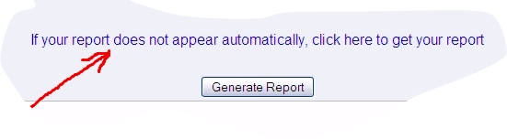
SSMD Professional CV - Available Now.
- Usage: Full Primary CV
- Can be modified as a word document to create various short CV versions.
- This UWO faculty standard CV report contains all activities in the STAR database except
- Department / Division meetings attended - Time Allocation
- Goal Setting and Review - Clinical Profile

UWO APTD (Academic Promotions Teaching Dossier) - Available Now.
- Usage: Promotion and Tenure Complete Teaching Dossier
- This report can function as a standalone Teaching Dossier.
- We are planning an update to the Teaching Dossier, available with v5.14

UWO APCV (Academic Promotions CV) - Available Now.
- Usage: Promotion and Tenure
- This report coupled with the APTD, (as a set) contain all activities in the STAR database except
- Department / Division meetings attended - Time Allocation
- Goal Setting and Review - Clinical Profile
- All activities in STAR not captured on the APTD are contained in this report.

BioSketch - Available Now.
- Usage: Presentation Introduction
- This one-page report contains the faculty portrait, and the BioSketch paragraph describing the member's career.

Detailed Activity Report - Available Now.
- Usage: Internal Summary
- Specify a start and end date and have the STAR system retrieve all records which occur in that specified period.
Department of Surgery CDP: - Available Now
- Department of Surgery Faculty members Only
- This report will instruct the database to only capture activities for a user selected academic year.
- The report will assign points to the various activities completed, as directed by the Department of Surgery FMC
- Section 7 of the report will total the points so that the faculty can be compared to another faculty within the dept.

Main Menu - Help

Help
“The Help screen will allow you access the first level support system. By clicking on the “?” icons found throughout star, you can access specific areas of the help document, to view the context sensitive help information. If the help documentation does not answer your question, then you can proceed to the second level STAR support by contacting your departmental STAR Coordinator. If they cannot answer your question, then they will escalate the question to the Faculty Administrator.”

First Level Support
Source: Help Files & Project Website
Page: http://www.star.schulich.uwo.ca/
Notes: See Below

Second Level Support
Source: Department Coordinator
Page: Email or Telephone
Notes: http://www.star.schulich.uwo.ca/departments.html

Third Level Support
Source: Star Faculty Administrator
Contact: Derrick Gould x32115

Documentation
“The Documentation screen will allow you to download and open/print any of the system documents.”

Available Documents
General: Help file
Instructions: Instruction Manual v1.0
Videos: http://www.star.schulich.uwo.ca/vids.html
Support: Escalation Procedure

Glossary

“The Glossary page will explain any terms or acronyms which may not be intuitive.”

* - Pick list contains an “Other Specify option”
ACAHO - Association of Canadian Academic Healthcare Organizations
AFMC - Association of Faculties of Medicine of Canada
AP – Academic Promotions
CAPER - Canadian Post-MD Educational Registry
CV – Curriculum Vitae
CCFP - Certificant of the College of Family Physicians of Canada
CCV – Common CV (CIHR)
CDP – Career Development Plan
CFPC - College of Family Physicians of Canada
CIHI - Canadian Institute for Health Information
COACH - Canadian Organization for the Advancement of Computers in Health
CPD – Continuous Professional Development
CPA – Creative Professional Activities
CPSO – College of Physicians and Surgeons of Ontario
CSA - Canadian Standards Association
CME – Continuing Medical Education
CMPA – Canadian Medical Protective Association
FMRAC - Federation of Medical Regulatory Authorities of Canada
MBR – Merit Based Recognition
MCC - Medical Council of Canada
MINC - Medical Identification Number for Canada
PIPEDA - Personal Information and Protection of Electronic Documents Act
PME – Postgraduate Medical Education
RCPSC - Royal College of Physicians and Surgeons of Canada
STAR – Staff Tracking and Activity Reporting
TD – Teaching Dossier
UME – Undergraduate Medical Education

Tips, Tricks and Hints

“This section of the guide will explain any commonly made
mistakes and further explain any items which not be clear”

Teaching Dossier (NEW) - Report Update for 2026

Some of the changes / updates to the New Teaching Dossier report for 2016 include:

Department Standard Course Descriptions on the Program Teaching Page.

(for each course in STAR - where available), The Clinical Department Administration can input a short paragraph describing the Standard Course Content for each of the courses listed in STAR. Since this feature is brand new, most departments have not yet had time to gather / input the Standard Course Descriptions.

Faculty Member Additional Comments on the Program Teaching Page.

The Faculty Members can add some additional information to the Standard Course Description by adding some comments to the 'Faculty Member Additional Comments' field on the Program Teaching Page.

Note: For the comments to be added, the Include Member Additional Comments check box needs to be checked. (One record per course is all you need)

Add comments to the Academic Committees page.

(To allow the member to describe their involvement or impact)

Find the 'Contribution' field on the Administrative Committees page, and add a short paragraph describing how your activities impacted the committee)

Add impact to the Publications page relating to teaching.

(To allow the member to describe the 'impact' of the publication)
When the 'Education Publication' checkbox is selected on the Publications page, the 'impact' field will be editable, and the user can add a short paragraph describing the impact of the publication.

Note: The impact field on the Publications page only prints on the New Teaching Dossier report.

A new table which shows teaching evaluation score trends.

The Teaching Evaluation Trends table requires the input / upload of teaching evaluation scores from a system like One45. We are already working with all clinical departments to begin the process of uploading the required teaching evaluations data.

Number of Comparison Years to show in tables.

This is a user selectable option to determine how many years of teaching evaluations should be used for comparison / trending. This also assumes that the Teaching Evaluations page in STAR contains that number of years of historical data.

Add comments to the Teaching Award records indicating what the award was for.

To allow the member to describe their award in a short paragraph.

Add outcomes to the Leadership Evidence records indicating the 'outcomes' achieved.

To allow the member to describe their involvement or impact in a short paragraph.

Add involvement to the Grants and Clinical Funding records indicating 'Your Involvement'.

To allow the member to describe their involvement or impact in a short paragraph.

Faculty Assessment Report Update

We have made two minor changes to the FAS Report output with STAR 5.18. These changes are very minor and do not affect the import process. The changes are:

The FAS Report can now be printed out in PDF Format,

The Output Filename will change to allow for easier identification

Rest of Citation Field Update

STAR users will notice that the “Rest of Citation’ fields on all STAR pages are now greyed out.

The contents of the ‘Rest of Citation’ field are still in the field, and it can still be edited, however to discourage people from populating the ‘Rest of Citation’ field.

The ‘Rest of Citation’ field is still editable by clicking on the ‘Edit Rest of Citation’ checkbox.

Frequent Activities View

Introducing a new Dynamic (Purple) menu called Frequent Activities View. This view summarizes the ‘busy’ screens in STAR into one menu. Same screens just presented to you in a different order.
Coupled with the Monthly Activity Tracking document, this is a concise, and easy way to enter your repeating or most common activities.
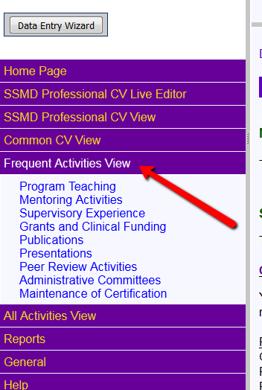
Figure 1 New STAR Menu – Frequent Activities View

Publications Data Grid Update

The Publications Data Grid has been updated to split the citation data from Journal Name field. This is just a visual change on the Data Grid, no data has been modified.
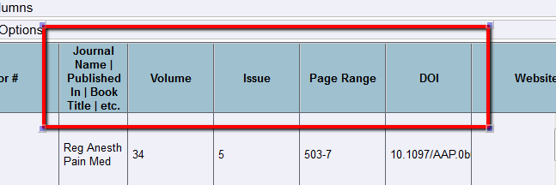
Figure 2 The new look of the Publications Data Grid

Create a MOC record directly from the Presentations screen
Users now have the ability to create a CME Maintenance of Certification record directly from the Presentations screen. A checkbox called Add MOC Record at the top of the presentations data entry screen will automatically create one of the following records automatically.
Section 1 – Accredited Conferences / Small Group Learning
(Royal College)
OR
Section 1 – MainPro M1 / Conferences, Courses and Workshops / Group Learning
(Canadian Family Physicians College)

This is intended for conferences that were both attended and presented.

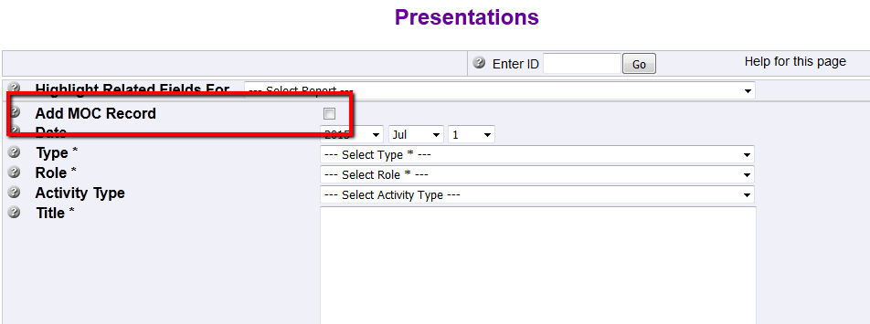
Figure 3 New Publications Checkbox – Automatically Add a MOC Record
Maintenance of Certification record after saving
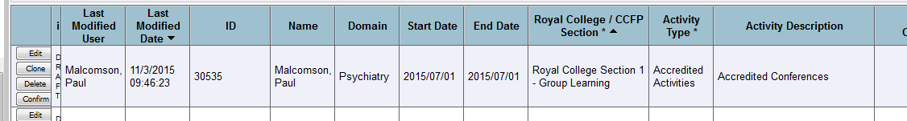
Figure 4 New MOC Record

Search

The Search feature has existed in STAR for several versions, however it is one of the least used features of STAR, yet at the same time it is one of the most powerful and time saving features.

Faculty Members can search their own STAR records, and Member Secretaries can search any of the member’s STAR records that they have access to.

If there is something specific that you are looking for in STAR, putting that word or phrase in the search bar, and click the search button, as seen below.

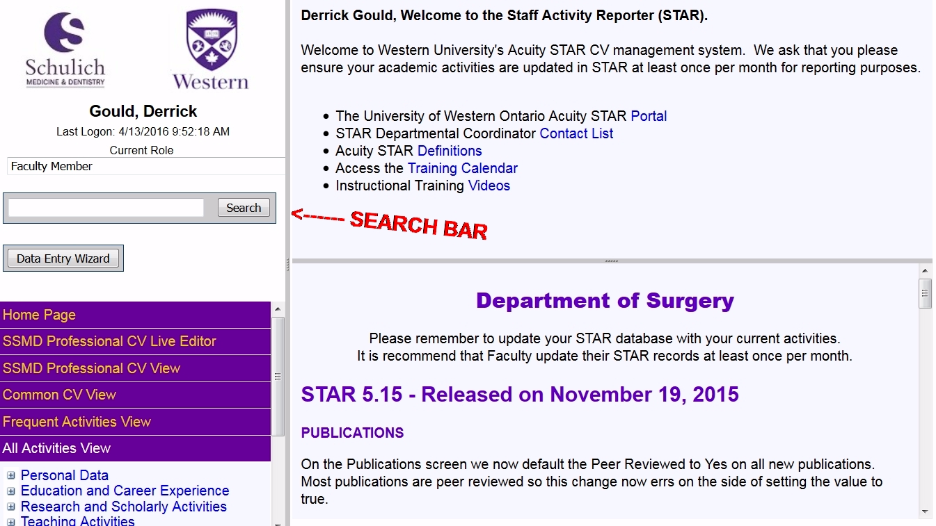
Figure 5: STAR Search Bar

SSMD Professional CV Report Screen
A checkbox has been added to the Professional CV generation screen to Include All Grants and Clinical Trials. This will print all grants and trials grouped by their status (Funded, Applied, Not-Funded, Declined, Rejected). Without this box checked, only Funded and Applied grants will print.

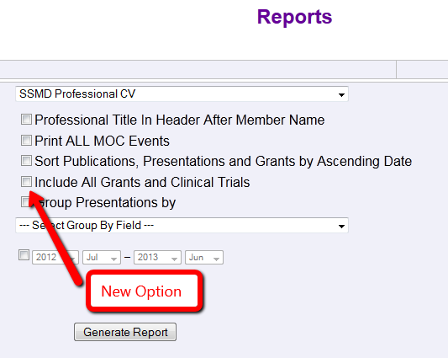

Data Entry Wizard

Click the Button

A new feature was added to STAR in v5.8 which allows a user to use a wizard to help guide them to the proper data entry screen. The button can be found in the left side menu, just above the purple menu system.

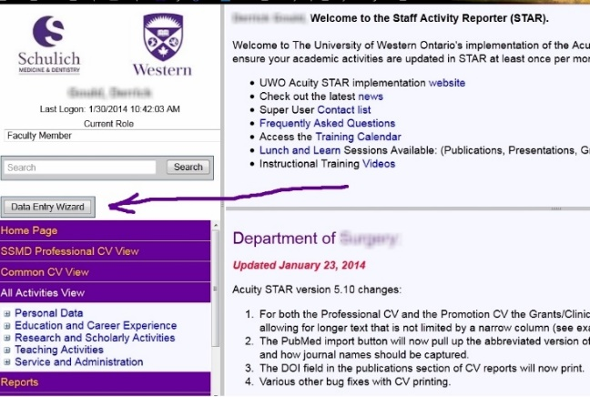
Figure 6: Location of the Data Entry Wizard Button

PubMed Go Button

Lookup PubMed Articles with the GO Button

A new feature was added to STAR in v5.8 which allows a user to enter any valid PubMed article ID into the PubMed Article ID box and click the go button. STAR will then send a query to PubMed and retrieve and populate the fields that PubMed sends back.

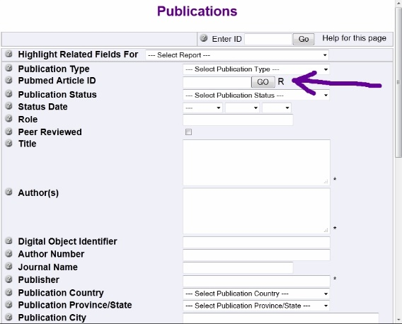
Figure 2.2: Location of the PubMed GO Button

Where to enter Abstracts
Published Abstracts:
Abstracts that are published in Journals or Supplements are correctly placed in the Publications screen in STAR. Please ensure that the publication type is set to “Published Abstracts” and that the “Conference Publication Type” is set to “Paper”.
Promotion Consideration:
Abstracts that are presented orally or as a Poster are correctly placed in the Presentations screen in STAR. Please ensure that the “Type” is set to “Abstract Presented” for Oral Presentations or to “Poster Presentation” for Poster Presentations. For any member who is a candidate for promotion, listing the Abstracts which are presented orally or as a Poster can be very important for promotion consideration. The abstracts that are numbered beginning with an O (ex: O17) are abstracts that were orally presented, and abstracts that are numbered beginning with a P (ex: P25) are abstracts that were presented as a poster at the conference

Where to Enter Continuing Medical Education
CME Events can be entered in many places in STAR, so it is important to know the role
or activity the faculty member wishes to record.

If faculty was attending a conference or course and received MOCOMP credit:
Personal Data | Maintenance of Certification | Section 1 – Accredited Group Learning Activities

If faculty was attending a conference or course and did not received MOCOMP credit:
Personal Data | Maintenance of Certification | Section 2 – Other Group Learning Activities

If faculty was presenting at a conference or course outside Schulich:
Research and Scholarly Activities | Presentations | Activity type = Continuing Medical Education

If faculty was presenting at an accredited CME event within Schulich: (rounds)
Teaching Activities | Program Teaching | Program = Continuing Medical Education | Role =
Presenter

Filtering Data Grids (All Activities View)

If you enter records in STAR and you cannot find them once you have received the “you saved a record” confirmation, the likely reason is because the data filters are set to show you only a certain subset of records, which are not set to show you the record(s) you are looking for.

Setting the Data Filter to show you 1950-Present will not allow any records which have been saved without an entry in the “Status Date” field to show up, because a field with no
date does not fall within the specified range.

Only setting the Start Date year filter to --- will allow you to see ALL records, regardless of date. To clear the data filter, select the year checkbox and set the values to “from --- to present”.

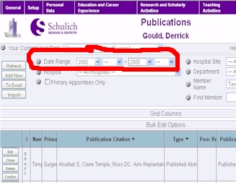
Figure 2.4: Date Range Filter Area

SSMD Professional CV Options

The options below enhance the flexibility of how the SSMD Professional CV can be created.
- A checkbox to append “, Professional Title” in the document header after the Member Name
(unchecked only the member name will print in the header section)
- A checkbox to include Maintenance of Certification activities attended
(unchecked, activities attended will not print)
- A checkbox to sort Publications, Presentations and Grants Ascending by Date, instead of descending
(unchecked these activities will print descending by date
- A checkbox and dropdown to group Presentations by Geographic Scope OR Activity Type
(unchecked presentations will print ungrouped)

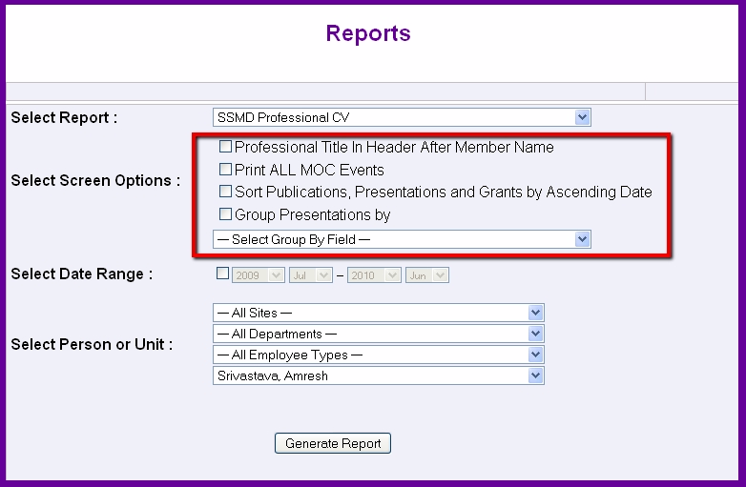
Figure 2.6: New Options Printing the SSMD Professional CV

Grant Status Options

Grants saved in STAR have the option to have one of five different ‘grant status’s’
- Applied…Have not yet been advised of the decision to fund the grant.
(Prints on all CV’s)
- Received…Have been awarded funding for this application.
(Prints on all CV’s)
- Not funded…This Application was approved but not funded by the granting agency.
(Does Not Print on Professional CV)
- Declined… Funding for this Application was declined by the applicant.
(Does Not Print on Professional CV)
- Rejected…Funding for this Application was rejected by the granting agency.
(Does Not Print on Professional CV)

Frequent Activities View
We have added a new Dynamic menu called Frequent Activities View. This view summarizes the ‘busy' screens in STAR into one menu. Same screens just presented to you in a different order.
Coupled with the Monthly Activity Tracking document, this is a concise, and easy way to enter your repeating or most common activities.

Publications Data Grid
The Publications Data Grid has been updated to split the citation data from Journal Name field. This is just a visual change; no data has been modified.

Create Maintenance of Certification from Presentations
You now have the ability to create a CME Maintenance of Certification record directly from the Presentations screen.
A checkbox called Add MOC Record at the top of the presentations data entry screen will automatically create a Section 1 /Accredited Conferences / Small Group Learning (Royal College) OR Section 1 – MainPro M1 / Conferences, Courses and Workshops / Group Learning (Canadian Family Physicians College) record for you.

This is intended for conferences that you both attend and present at.

Peer Reviewed Publications

On the Publications screen we now default the Peer Reviewed to Yes on all new publications. Most publications are peer reviewed, so this change now errs on the side of setting the value to true.

SSMD Professional CV Live Editor
The CV Live Editor will allow editing of the SSMD Professional CV on the screen in place via a New STAR Interface. This new interface will simulate the ability to edit the CV as though it was a MS-Word interface.
As this is a new feature in STAR, we request that all users to let their STAR Coordinator know if you have any problems or suggestions for improvement.

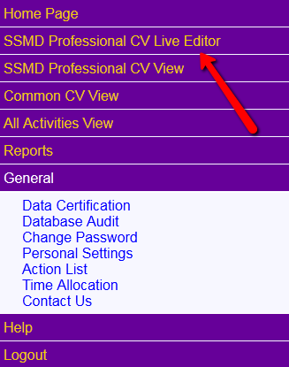
Fig 1: SSMD Professional CV Live Editor

Database Audit
The Database Audit feature is found in the General Menu.
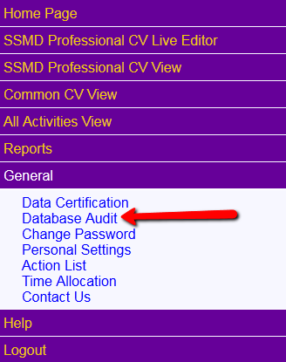 | This new feature allows a user to search their entire database, or any individual STAR page, for "Mandatory Fields" which contain no data.  The search result will bring all records which require updating to meet minimum “Mandatory Filed” requirements to one page and group the records by page.  Fixing all of the items in this search result will greatly increase the quality of the CV output, as many of the fields which are marked as mandatory are required for sorting or grouping of CV activities.
Fig 2: Database Audit in the General Menu.

After clicking on the Database Audit feature in the General Menu, simply select which pages to be audited by adding a checkmark to the box beside the page name. Alternatively, checking the box labeled “Audit all Records” will automatically put a checkmark in all check boxes.
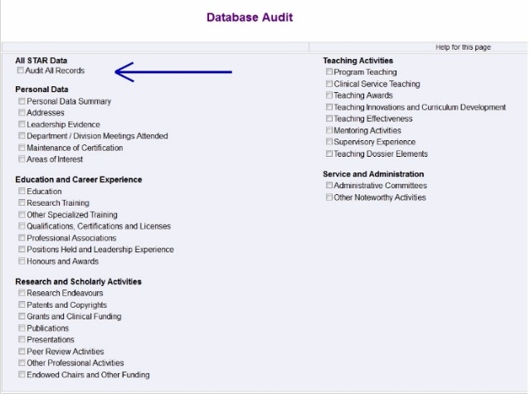  Fig 3: Selecting Pages to Audit | 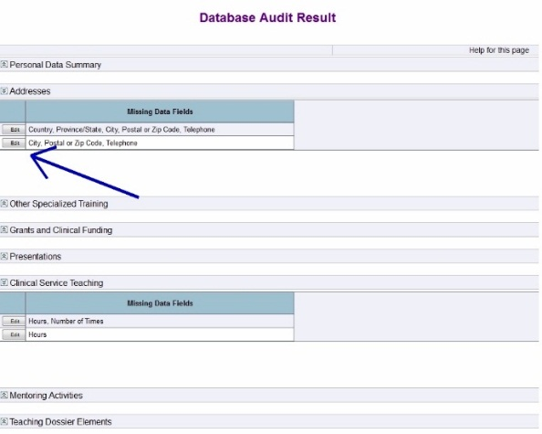  Fig 4: Sample Audit Result
As seen in the example above, a user can clink on the edit button on the corresponding row of any returned search result, to be taken to that record for update. Note that the record cannot be resaved until all mandatory fields are completed.
Also, please note that the missing data fields are shown on the search result in figure 4 above.

Multiple PubMed Import
There is a feature now available on the Publications | Import page in STAR. As seen below, simply add all PubMed numbers to the Import Data field with one PubMed Number on each line. Any PubMed number that already exists in the user’s database will be updated or refreshed to include the latest or updated information. There is no limit to the number of PubMed numbers you can input at one time, but practically we suggest doing no more than 25 at a time.

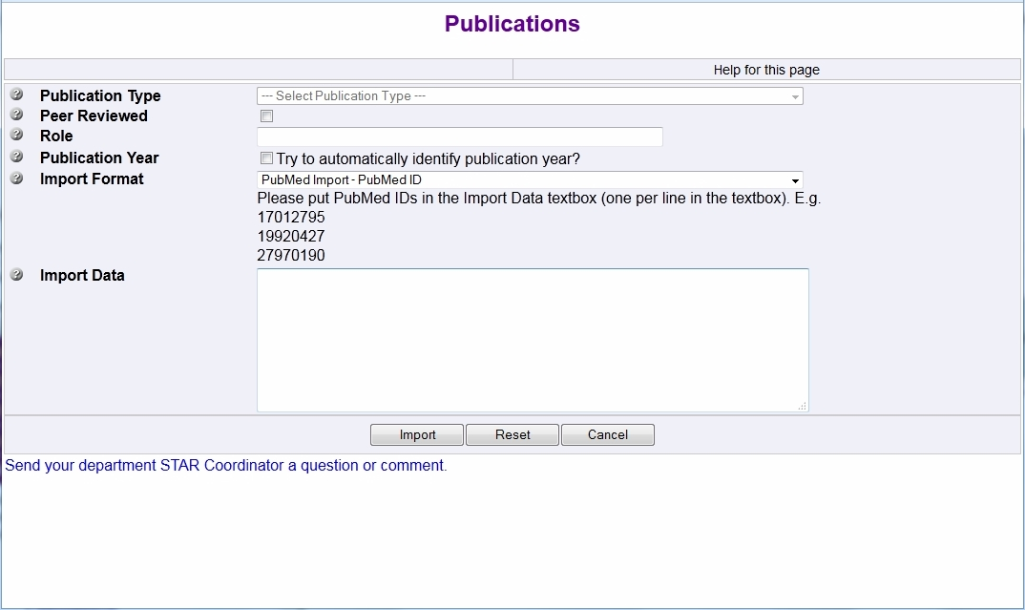
Fig 5: Multiple PubMed Import

If you have questions about any of these improvements, please contact your STAR coordinator.

Document Revision History

Document Modified By | Date | Type
Derrick Gould | April 2024 | Modifications for 5.32b
Derrick Gould | July 2024 | Modifications for 5.33b
Derrick Gould | February 2025 | Modifications for 5.34b
Derrick Gould | October 2025 | Modifications for 5.35b

