IHEL Experience at the JCRC in Uganda
My name is Rhidita Saha and I’m an incoming third-year medical student at Western University. I had the incredible privilege of doing a summer international elective alongside my classmates Hana and Jade, through Schulich’s International & Healthy Equity Learning (IHEL) program at the Joint Clinical Research Center (JCRC) in Kampala, Uganda. The elective was from June 28th to July 12th, 2025. In this blog, I will share some of my key takeaways and favourite photos from this experience.
Experiences at the JCRC
All the staff at the JCRC were so kind and welcoming to us. They took time out of their own day to check-in on us, to give us tours of their offices and clinics, and to inform us when any procedures that might interest us were taking place. We got to rotate through the wards, the adult outpatient clinic which focused mostly on HIV care, the pediatric clinic, the early infant HIV detection and prevention clinic, the tuberculosis clinic, the sickle cell clinic, RBC transfusions unit, the renal clinic, the phlebotomy lab, and more! The patients at the JCRC were also so kind to let us observe their appointments and hear their stories. The staff would welcome us and teach us about their work at every place we stopped by. They also invited us to join special talks they had at the institute, including an ECG reading workshop, and a workshop for counsellors to support patients experiencing bereavement. I really appreciated the willingness of people to teach us and to answer all our questions.
During the clinical encounters at the JCRC, I got to truly appreciate the importance of a psychosocial and inter-disciplinary approach to healthcare. For example, patients with HIV visiting the clinic would first see the nurse to get their vitals and then would visit the doctor to discuss concerns and renew their prescriptions. After that, they would see a counsellor if they had issues with medication adherence, or any other concerns including stress, mental health issues, self-stigmatization, family issues, etc. Then they would go to the phlebotomy lab to get their routine bloodwork done and then would go the pharmacy to pick up their medications. Lastly, if needed they could also talk to the nutritionist, expert patients, and other allied health care providers at the clinic.
I also learned about the limitations of healthcare resources and delivery at the JCRC and in Uganda in general. The staff taught me about cultural, socioeconomic, and structural barriers to accessing healthcare in Uganda. It was an eye-opening experience and makes me motivated to learn more about barriers to healthcare in my local community in Canada and globally.
I was also inspired by the strong partnership between the JCRC and Schulich. The mutual partnership and commitment were evident – we saw a building named after Dr. Eric Arts and we also saw the tree that Dean Dr. Yoo planted during his visit. This level of partnership made it possible for us as medical students to come to the JCRC and for the Global Health Master’s students to spend such a significant amount of time here too.
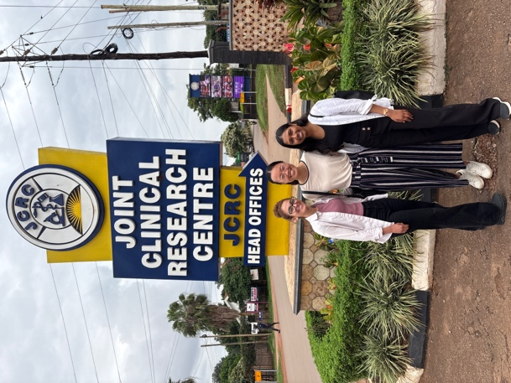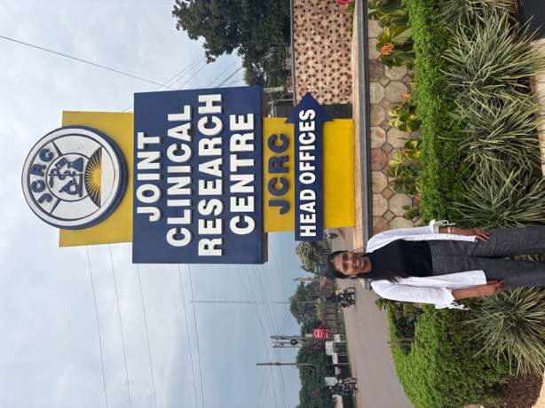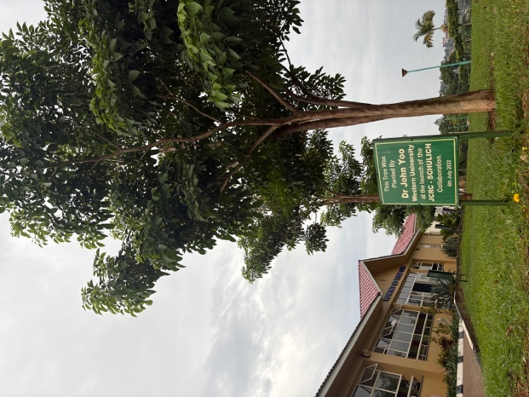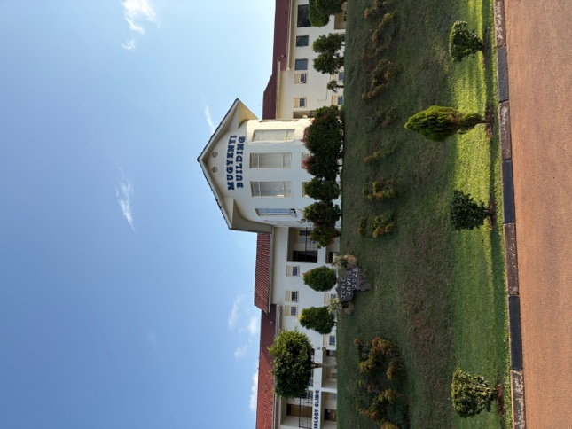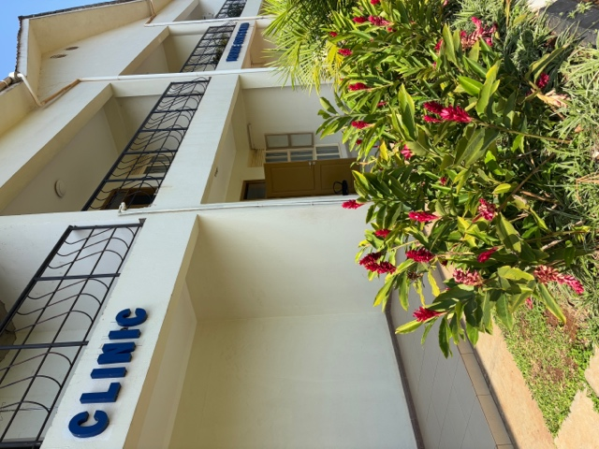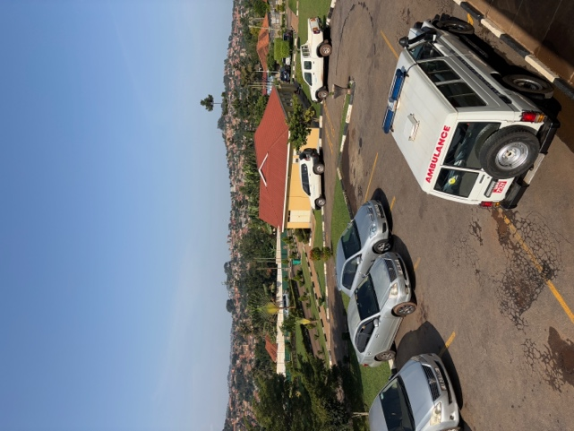
Participating in community outreach initiatives
Participating in community outreach was such a valuable learning opportunity. I got to see first-hand how community level health screenings and preventative measures are delivered. During these outreach events, we screened for HIV using a rapid test, delivered pre-exposure prophylaxis for HIV, screened for tuberculosis using sputum samples, delivered condoms and family planning education, and monitored non-communicable diseases like hypertension. Even though this was out in the open, the staff still prioritized patient confidentiality and comfort. I learned how the staff build rapport with members of rural communities, especially youth so that they feel comfortable sharing personal information with community health workers. We got to join 2 visits to rural communities and 1 visit to a corporate event for National Water.
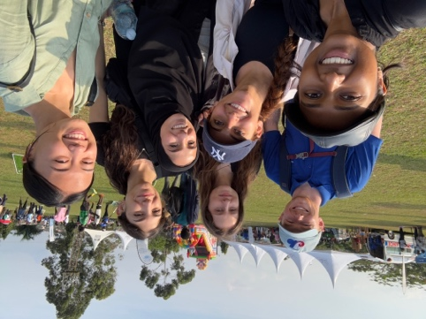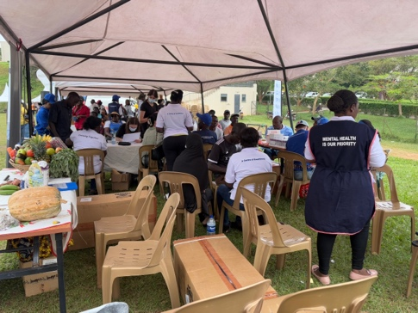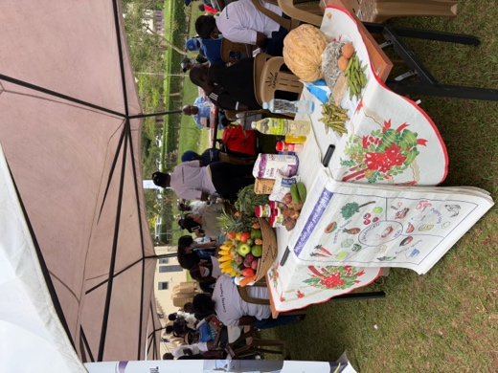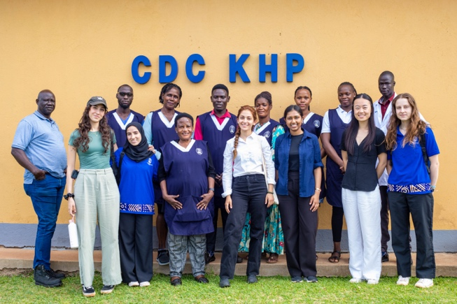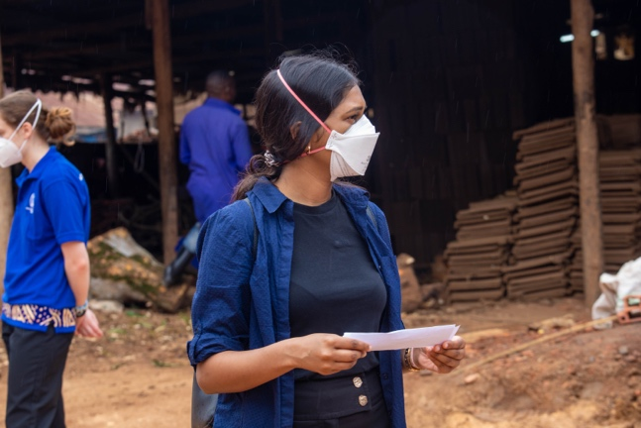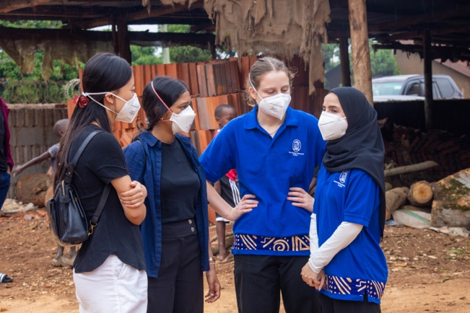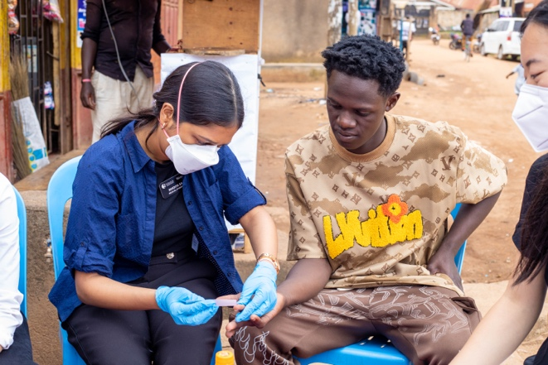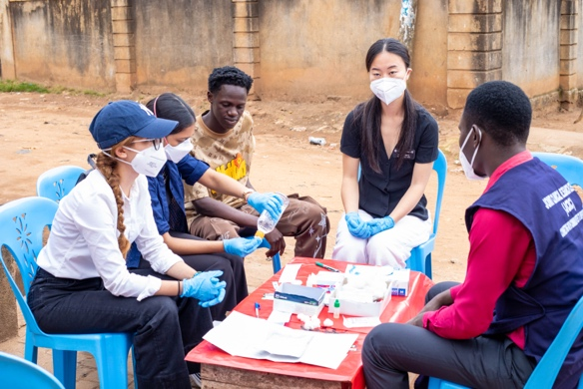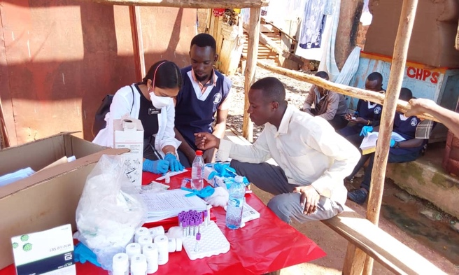
Exploring local foods and the city of Kampala
We had the opportunity to meet the Global Health master’s students in Kampala for their placement, and they were very friendly. They showed us their favourite restaurants in city center and the crafts market where we got some souvenirs. We tried the JCRC’s canteen food which had local Ugandan cuisine, and it was very tasty. We also bought fresh fruit from a vendor on the street and the fruits were so delicious that we kept going back and buying more!
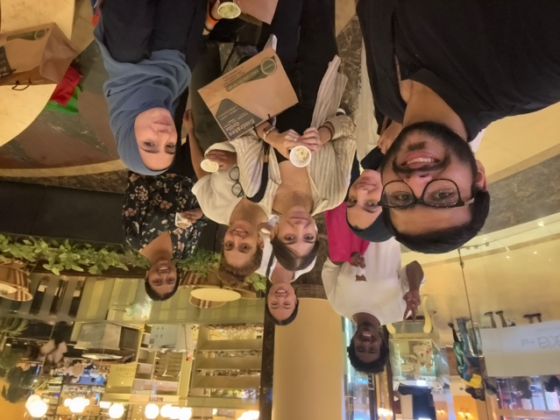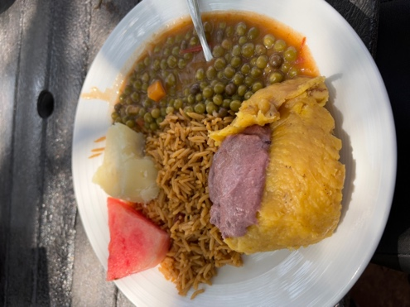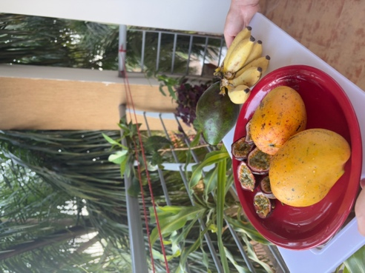
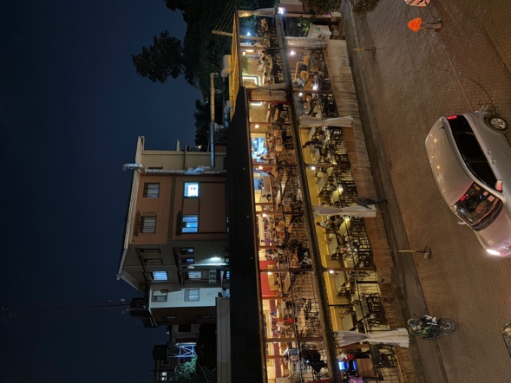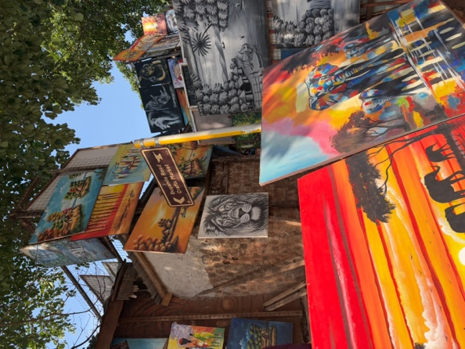
Experiencing the natural beauty of Uganda
The weather in Uganda is amazing! It was at times better than the summer heat we experience in Ontario. There was a lovely breeze and it was not too humid. We were also mesmerized by the natural beauty of Uganda. There is so much greenery everywhere and the rolling hills with orange-roofed buildings made the landscape so beautiful. We also took a day trip to Jinja where we went on a boat tour to see the source of the Nile River. During the boat tour, we learned about the local fishing economy, and the variety of bird species in Uganda. We also visited the gorgeous Busowoko falls.
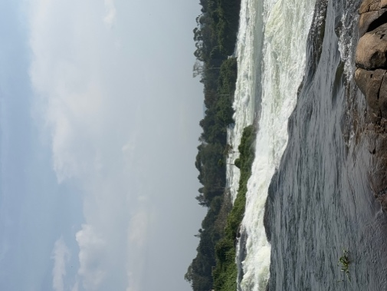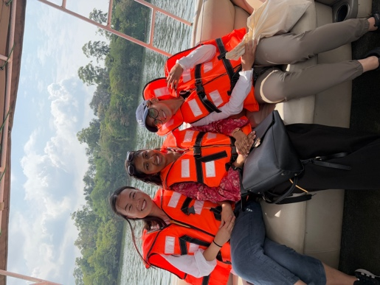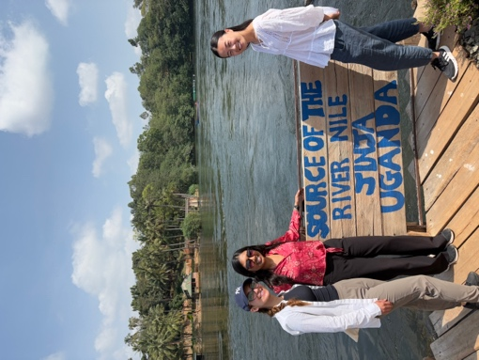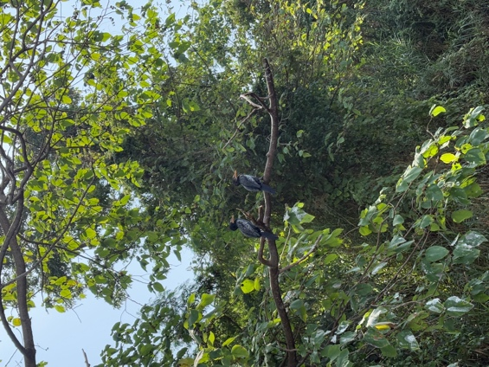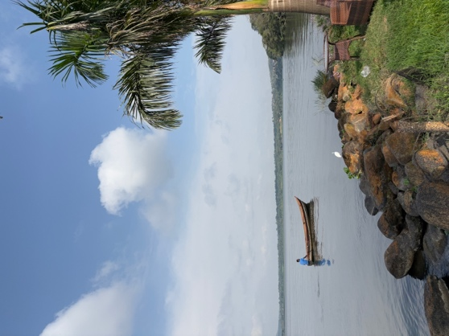

I am very grateful for the opportunity to do an international elective in Uganda and for the kindness and warmth of all the people at the JCRC. I also really appreciate the IHEL travel grant awarded to me to support this experience. I made lots of memories with Hana, Jade, and the Global Health master’s students. I have learned so much during my time in Uganda and I look forward to sharing my experiences with my peers in Canada. I hope to carry my learnings forward in my future career as a doctor and to one day contribute to global health initiatives as a physician!

