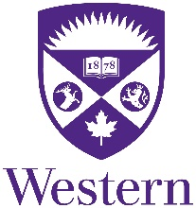

Your Logo(s) Here

Certificate of Attendance

This is to certify that

Title First Name Last Name

Attended the
<<Name of Course>>

Held on Month Day, Year
City, Province/State

This event is an Accredited Group Learning Activity (Section 1) as defined by the Maintenance of Certification Program of the Royal College of Physicians and Surgeons of Canada, and approved by Continuing Professional Development, Schulich School of Medicine & Dentistry, Western University. You may claim a maximum of XX hours (credits are automatically calculated).
This one-credit-per-hour Group Learning program meets the certification criteria of the College of Family Physicians of Canada and has been certified by Continuing Professional Development, Schulich School of Medicine & Dentistry, Western University for up to XX Mainpro+ credits.
Each participant should claim only those hours of credit that he/she actually spent participating in the educational program.

