Learning Objectives Quick Tips

After reading this handout, you should be able to:
- Construct learning objectives for use in CPD program development

Well formulated learning objectives provide participants with an understanding of the knowledge, skills, behaviours, or attitudes they will gain as an outcome of the activity. They should address the identified needs of the target audience determined through the needs assessment process. Learning objectives must also be written from the learner’s perspective and be measurable.

Overall learning objectives need to be created for all activities, while session-specific learning objectives are required when the activity involves more than one session (e.g., multi-session workshops, conferences with multiple presentations, etc.). Session-specific learning objectives can be developed by speakers with guidance from the SPC.

When writing learning objectives, the following four (4) steps are recommended:

- Begin the statement with an opening statement similar to the following:
Overall example: “At the conclusion of this conference, participants will be able to …” Session-specific example: “At the conclusion of this presentation, participants will be able to…”

- Use an action verb to describe what information, skills, behaviours, or perspectives the participant will gain by engaging in the activity.

- Describe the knowledge, skill, or ability a participant will gain from attending the activity

- Contextualize the statement, and the standards depicting success, if necessary.

Learning objectives need to consider and integrate CanMEDS, and CanMEDS-FM roles, beyond simply “Medical Expert”, and “Family Medicine Expert”.

Learning objectives need to be made easily available to participants before they register for an activity so they can determine whether the activity will meet their learning needs. This can be done through the activity registration page and / or through promotional material.

Learning objectives must also be provided at the beginning of each activity through an agenda or activity program.

Participants must also have an opportunity to evaluate a program’s learning objectives. This is a required question within the Evaluation Form. See the Evaluation Section of this Guide for information on the Evaluation Form.

Learning Objective Template:

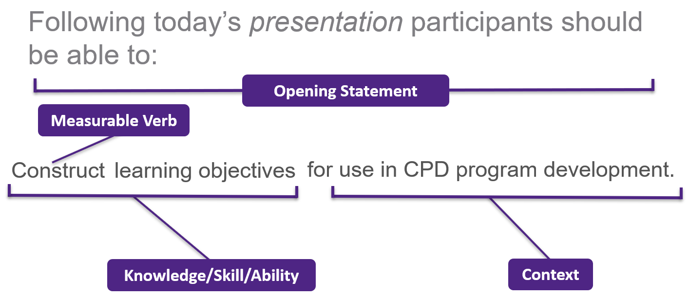

Step |  | Description
1 | Opening Statement | Session, Course, Program, Conference, Webinar, Etc.
2 | Select a measurable verb | For example:  Identify, Recognize, Describe  OR  Refer to one of the following verb lists:  - Royal College, CFPC, Bloom’ s Taxonom y
3 | Knowledge/Skill/Ability | What will the participant gain from this activity?  - Learning objectives should reflect needs assessment data!
4 | Context | Where/How would a participant use this information?  Is there a standard participants are expected to achieve? For example:  - Completing a specific exam  - To enable safe patient management

Quick Tips:
- Understanding, knowing, appreciating, and learning are UNACCEPTABLE – see The Sinister 16
- Networking, while a good goal, is not an acceptable learning objective.
- Objectives should be written from a learner’s perspective (What will learners be able to do?)
- For a multi-session activity, the program & each session need their own objectives.
- A program should aim to have at least two learning objectives unless it’s a very short session.

