**Division of Urology**

**Competency Committee (CC) Meeting**

**Standard Operating Procedure**

Created: November 25, 2019

Table of Contents

[***Urology EPA Reference*** 3](#_Toc33440496)

[Timelines 3](#_Toc33440497)

[***Preparing for CC Meeting*** 4](#_Toc33440498)

[*Review Previous CC Meeting Report for Resident* 4](#_Toc33440499)

[Videos on to use Elentra reports 4](#_Toc33440500)

[Where to find the reports 5](#_Toc33440501)

[How to use reports for CC meeting preparation? 6](#_Toc33440502)

[***Conduction of Competency Committee Meeting*** 8](#_Toc33440503)

[*Open Current CC Meeting Report for Resident* 8](#_Toc33440504)

[*Completing Summary of Review by Competency Committee* 9](#_Toc33440505)

[**Navigating Elentra UWO** 10](#_Toc33440506)

[*Logging in and selecting Resident for Review* 10](#_Toc33440507)

[*Elentra CBME Dashroom* 11](#_Toc33440508)

[*Determining Number of Assessment Since last CC Meeting* 12](#_Toc33440509)

# ***Urology EPA Reference***

The EPAs for Urology are categorized into 4 stages of training: Transition to Discipline; Foundations if Discipline; Cores of Discipline; and Transition to Practice.

Details of each EPA are found within the Urology EPA Summary Excel File, which is discussed in “Preparing for CC Meeting”.

## Timelines

The following are suggested timelines for each stage of training:

1. Completion of Transition to Discipline after 6 months
2. Completion of Foundations to Discipline after 18 months
3. Completion of Cores of Discipline after 42 months
4. Completion of Transition to Practice before end of residency

# ***Preparing for CC Meeting***

## *Review Previous CC Meeting Report for Resident*

### Videos on how to use Elentra reports

You can watch an overview of the reporting in one of the video clips below.

|  |  |
| --- | --- |
| Individual Resident EPA reports:  [https://youtu.be/8t9rXQwrZFw](https://elentra.schulich.uwo.ca/)​  5 minutes, 24 seconds | [/var/folders/4_/66w1456n3_93y43ntgfbdw500000gn/T/com.microsoft.Word/Content.MSO/F8DD5E3.tmp](https://elentra.schulich.uwo.ca/) |
| Menu Bar in reports:  [https://youtu.be/NKBGHvaY35Q](https://youtu.be/8t9rXQwrZFw)​  1 minute, 56 seconds | [/var/folders/4_/66w1456n3_93y43ntgfbdw500000gn/T/com.microsoft.Word/Content.MSO/6C412CE9.tmp](https://youtu.be/8t9rXQwrZFw) |

### Where to find the reports

Once you log into Elentra, click on the ‘Reports’ link in the purple menu bar.

****

Once you click on the ‘Reports’ link in the purple menu bar, you will need to enter your login information again.

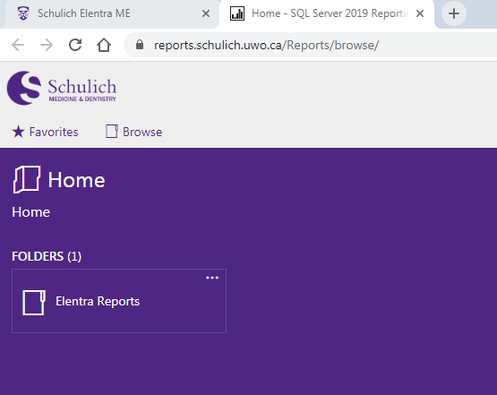

Click on “Elentra Reports”, then “PGME”, then “Resident EPA Summary”

By default, Level and Resident have all options selected. Select Level and then specific Resident.

Click on on top right corner.

### How to use reports for CC meeting preparation?

1. Focus on the “Goals for next CC Meeting”, “Comments” and “Next Steps” sections. Cross reference all remaining EPA with the Urology EPA Summary Excel file provided by the Program Administrator.
   1. Previous Reports can be found in the Division of Urology Shared Drive

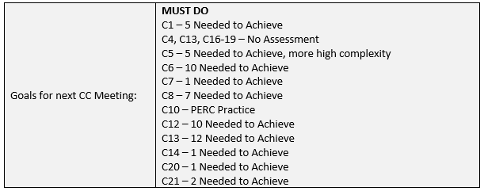

1. Change date on Elentra reports from previous CC meeting until date of review



1. For remaining EPAs, click on details for more information:

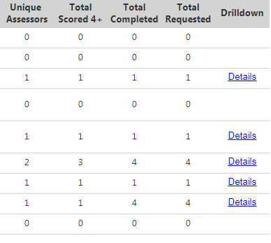

* 1. Information on EPA and requirements will be displayed:

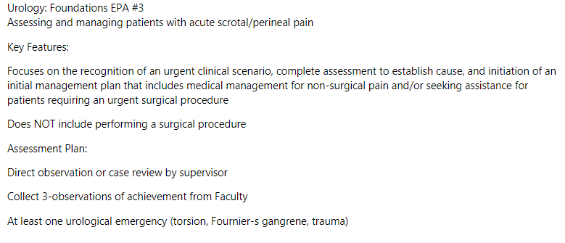

* 1. Ensure essential milestones and contextual variables are met (or at least have a satisfactory number achieved) followed by appropriate number of contextual variables (gender, location, complexity).
  2. Note down milestones that are consistently in progress despite adequate O-score. This will be discussed at CC meeting (either for revision of EPA versus competency of resident).
  3. Note down missing contextual variables and determine at CC whether this limits completion of EPA.
  4. Time-stamped comments are located at the bottom. Review comments and note any concerning patterns. 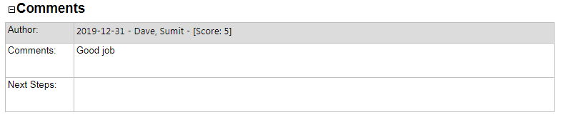

1. Repeat for all Remaining EPA from previous EPA meeting.

# ***Conduction of Competency Committee Meeting***

## *Open Current CC Meeting Report for Resident*

1. Document EPAs that have recently been ‘fulfilled’ in “New EPA Completed” Section.
   1. Copy and paste previously completed EPA + New EPA into “EPA Completed Notes”

|  |  |
| --- | --- |
| Date of CC Meeting: |  |
| New EPA Completed (C1, etc.): |  |
| EPA Completed Notes: | / Total |
|  |  |

* 1. Perform detailed assessment of EPAs deemed ‘Fulfilled’ and those deemed “Borderline EPA”. This may be based on inadequate milestones/contextual variables or comments.
     1. Note reasons for borderline and issues for discussion during CC Meeting in “Borderline Notes”

|  |  |
| --- | --- |
| Borderline EPA: |  |
| Borderline Notes (milestones, etc.): |  |

1. Review recent comments for ALL other remaining EPAs and note any ‘red flags’ or comments of significant ‘concern’ to patient safety or professional misconduct.
2. Review ITERS from rotations since previous CC meeting. These are found on the shared drive:
   1. Please fill out dates and rotation location, and note failures on rotations or concerns

|  |  |  |
| --- | --- | --- |
| ITERS | |  |
| Rotations since Last CC Meeting | Progress/Comments | |
|  |  | |
|  |  | |

1. Review procedure logs and determine completeness
   1. Determine whether the types and numbers are appropriate for stage of training
2. Review peer and co-worker evaluations
   1. Determine whether or not there are professional, leadership or communication concerns. These are to be discussed at CC Meeting.
3. OSCE Section
   1. For this section, please only review OSCE that occurred in the review timeframe. Note date, scores and areas of weakness.
4. AUA-IS and Quest
   1. Review AUAIS Score and Quest Results (Chiefs) and note down scores and areas of concerns/weakness.
5. Review Miscellaneous Emails
   1. Note down positive and negative incidents. Determine significance and appropriateness for discussion during CC meeting.

## *Completing Summary of Review by Competency Committee*

This section is a summary of your review. This should include the following:

1. Determine progression of resident based on:
   1. Review “Progress/Concerns”, “Remediation” and “Comments/Next Step” from previous CC Meeting. Determine if concerns are recurring and whether or not next steps have been satisfied from the evaluations in this CC meeting.
   2. Number of EPA with stage of training coupled with significant concerns related to limited exposure (contextual), or deficiencies with milestones or significantly concerning comment.
   3. Review appropriateness of current progress of resident as it pertains to the timeline within the stage of training.
   4. Significant concerns during rotations including failures and comments
   5. Significant knowledge gaps based on OSCE, AUAIS or Quest
   6. Significant concerns regarding professional, communication skills and leadership skills

|  |  |  |
| --- | --- | --- |
| Progress to Next Stage: | Yes | No |

* 1. Copy and paste remaining EPA minus “completed or borderline” EPA into “Goals for next CC Meeting” section. This should include any of the following: comments on number of assessment, reading plan, simulation practice, professional or communication recommendations.

|  |  |
| --- | --- |
| Goals for next CC Meeting: |  |

* 1. Using Remaining EPA coupled with milestones, contextual variables, comments and factors used to determine “progression” above construct recommendations to resident for next CC meeting. In addition, determine need for personal learning plan or remediation based on same information.

|  |  |  |
| --- | --- | --- |
| Remediation: | Yes | No |
| CC Final Assessment/Next Steps: |  | |

***NOTE:*** *The residents are responsible for reviewing every completed EPA as formative feedback and use this information in guiding the completion of the remaining EPAs.*

# **Navigating Elentra UWO**

## *Logging in and selecting Resident for Review*

1. Go to: [https://elentra.schulich.uwo.ca/](https://youtu.be/NKBGHvaY35Q)
2. Login with your UWO credentials
3. Click on Assessment & Evaluations on Top

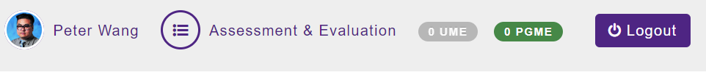

1. Click on My Learners:

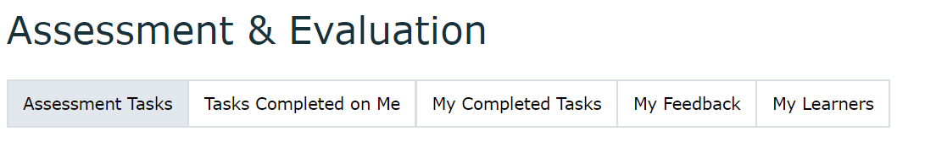

1. Select the Resident by clicking on “CBME Dashboard” underneath their name

## *Elentra CBME Dashroom*

The dashboard will give you information on the completed EPA separated by stage of training for the selected resident.

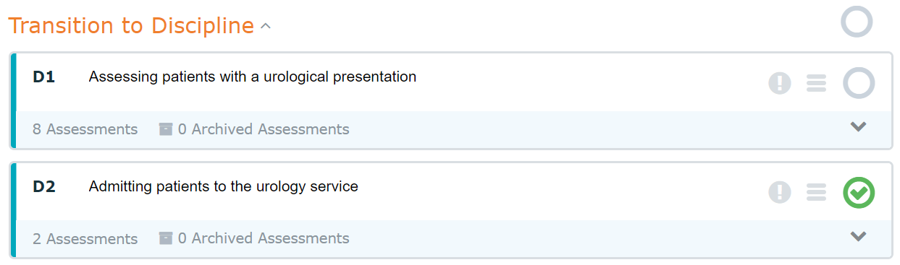

Green Checkmark indicated completed from previous CC meetings

Stage of Training

1. To view details, click on 

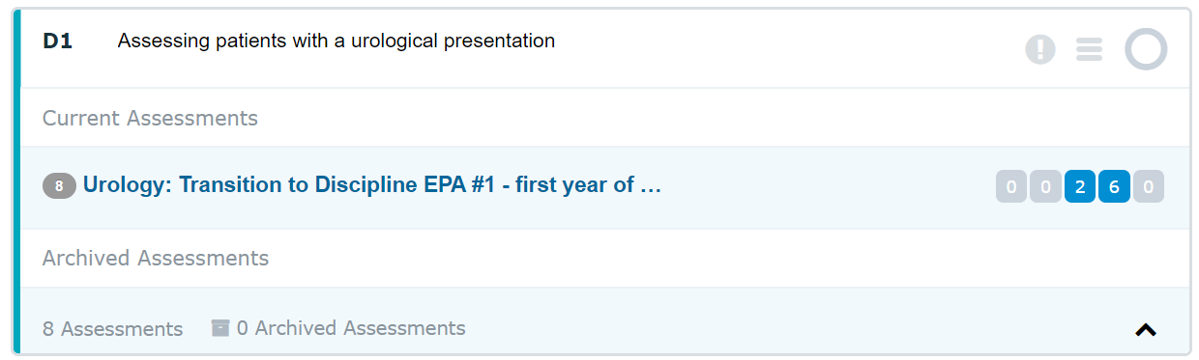

The numbered boxes indicate their O-score (1 to 5 from left to right). The blue boxes indicate the number of assessments. You can click on the blue box for further details on milestones and other contextual variables for all of the resident’s assessment for this EPA.

## *Determining Number of Assessment Since last CC Meeting*

1. In the CBME Dashboard click on Assessments



1. Select date from last CC meeting to cut-off date (2 weeks before) for current CC meeting

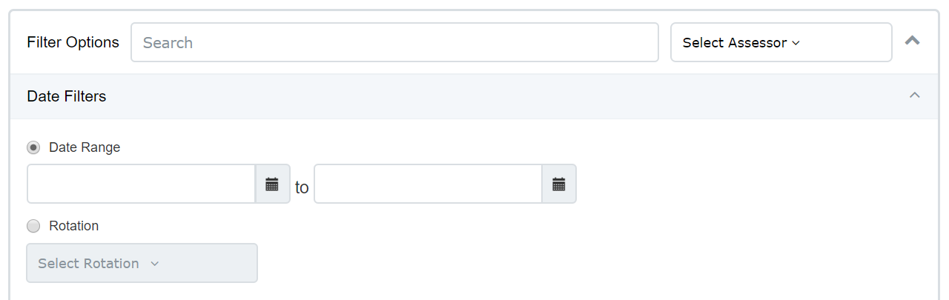

1. Click on blue Apply Filter Button and at the bottom of the new page the total number of assessments would be displayed (total filtered assessments)

