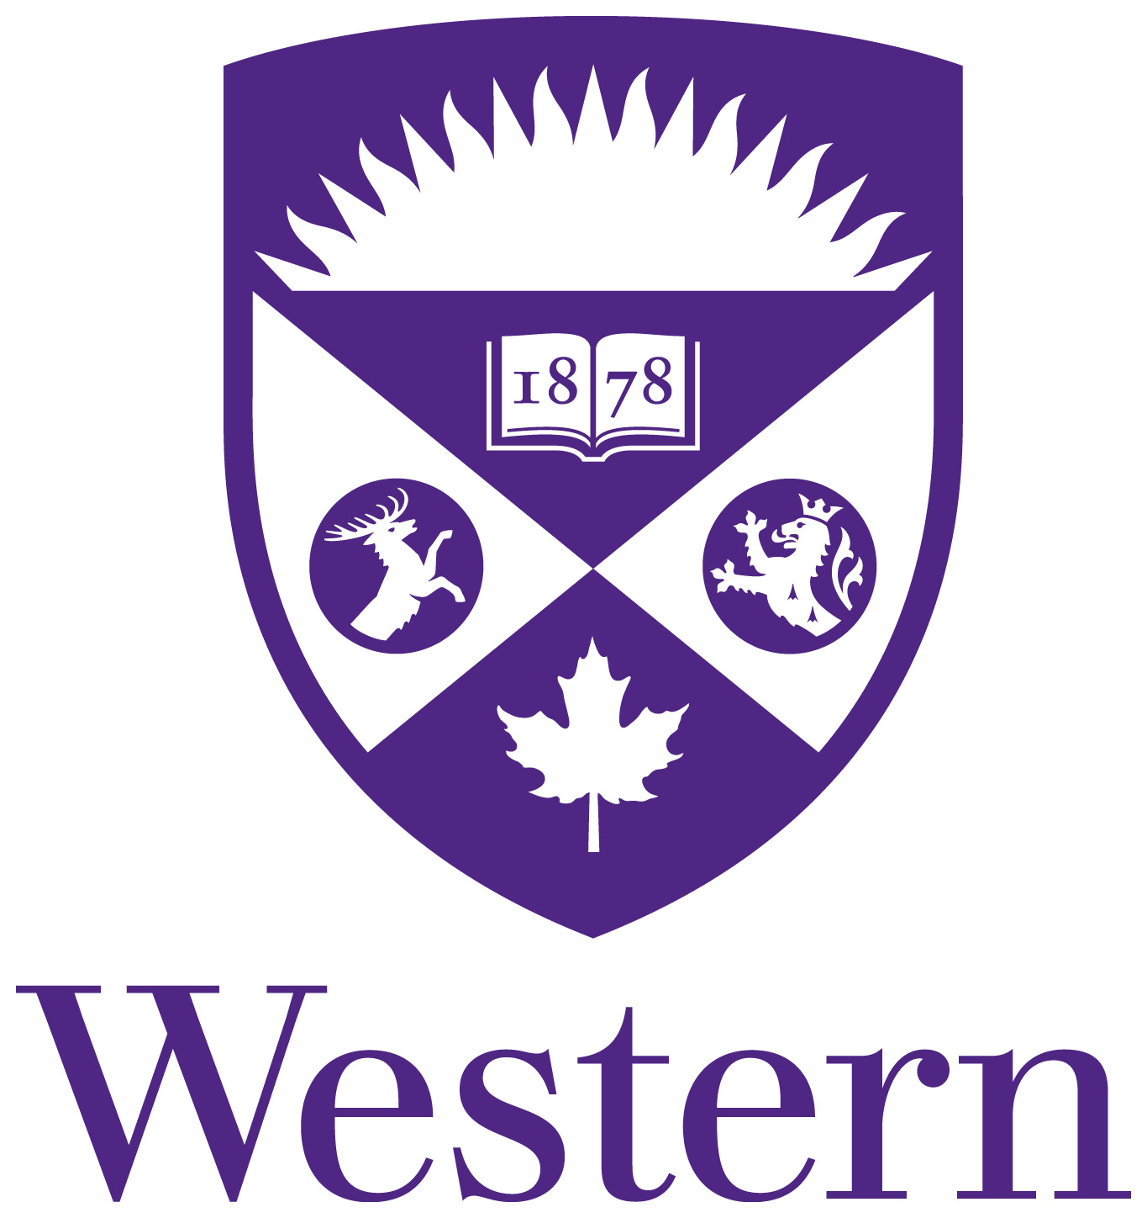

CARDIOVASCULAR GRAND ROUNDS – SEPTEMBER to DECEMEBER 2016

MONDAYS 8:00-9:00 am

AUDITORIUM “B”, 3RD FLOOR

LONDON HEALTH SCIENCES CENTRE - UNIVERSITY HOSPITAL

Videoconference to Victoria Hospital – Room B2-116
St. Joseph’s Health Care London – Room B2-075

DATE 2016 | SPEAKER | INSTITUTE/SPECIALTY
September 5 | Labor Day
September 12 | David McCarty | Echocardiography
September 19 | Pantelis Diamantouros | Interventional Cardiology
September 26 | Marco Mura | Respirology
October 3 | Jeff Healey | McMaster University
October 10 | Thanksgiving
October 17 | Sabe De | Echocardiography/Heart Failure
October 24 | CCC
October 31 | Michael Chu | CV Surgery
November 7 | Richard Kim | Clinical Pharmacology
November 14 | AHA
November 21 | Lorne Gula/Neville Suskin | London Heart Rhythm Program
November 28 | Samuel Siu | Echocardiography
December 5 | Jim Brown | General Cardiology
December 12 | Steven Gryn | Internal Medicine
December 19 | Lorelei Lingard | Centre for Education Research & Innovation
December 26 | Boxing Day
“This event is an Accredited Group Learning Activity (Section 1) as defined by the Maintenance of Certification program of the Royal College of Physicians and Surgeons of Canada, approved by The Division of Cardiology Education Committee - Western University”
Educational Grants Provided By:
Aegerion Pharmaceuticals (Juxtapid (lomitapide)), Amgen Canada Inc. (Repatha), AstraZeneca Canada Inc. (Brilinta (Ticagrelor)), Bayer Inc. (XARELTO® rivaroxaban tablet), Bristol-Myers Squibb Canada & Pfizer Canada Inc., (Eliquis (apixaban)), Medtronic of Canada Inc., Merck (Januvia, Janumet), Novartis Pharmaceuticals Canada Inc. (Entresto), Sanofi (Praluent), Servier Canada Inc. (Coversyl, Viacoram)

